GST loaded silicon-on-insulator diffraction grating

R. Minnullin^{1,2}, M. Makarov^{1,3}, and M. Barabanenkov^{1,3}
¹Moscow Institute of Physics and Technology (National Research University), Dolgoprudny, Russia
²JSC Molecular Electronics Research Institute, Moscow, Zelenograd, Russia
³Institute of Microelectronics Technology of RAS, Chernogolovka, Russia
e-mail: ramil.minnullin@phystech.edu

It is well known that progress in modern nanoelectronics through the scaling of standard planar CMOS technology is becoming more complicated with transition to feature sizes below 100 nm [1]. One of the prominent alternatives is nanophotonics, in particular, integrated silicon photonics due to its compatibility with CMOS manufacturing process. For over the decades extensive research in this field has resulted in a number of photonic applications in datacom, sensing and some other fields. Recently, it has been a great interest in photonics-based non-volatile data storage and neuromorphic applications that naturally incorporate phase-change materials such as Ge-Sb-Te (GST) alloys [2, 3].

In this paper, we start with a consideration of a thin-film GST diffraction grating deposited on a silicon-on-insulator (SOI) waveguide with 220 nm thick silicon and 1 µm thick buried oxide layer. Earlier in [4], we have mentioned several advantages such diffraction-grating-like GST formation can have beyond regular continuous film deposition. These are: i) lowering energy budget for optically induced GST phase transition utilizing resonant properties of the grating; ii) providing a simple way of GST phase verification on the basis of the grating reflection spectra; iii) and also, enabling an alternative input of light into the structure with different efficiencies depending on the GST phase.

However, considering the diffraction grating solely as an input (output) element, optimization of a certain number of parameters is needed. These parameters include input angle of incidence, grating period (pitch), filling factor (duty cycle), and height, which is also an etching depth. Since GST is typically deposited as thin films with thickness 10–30 nm because of its strong light absorption, the resulting grating height can be inadequate for the efficient coupling to the waveguide. Hence, we propose to etch further in the silicon layer, which will lead to the formation of a composite structure – SOI diffraction grating “loaded” with GST (Fig. 1a). We demonstrate that even shallow additional etching of silicon (5–30 nm) yields significant increase in the excited mode profile (Fig. 1b).

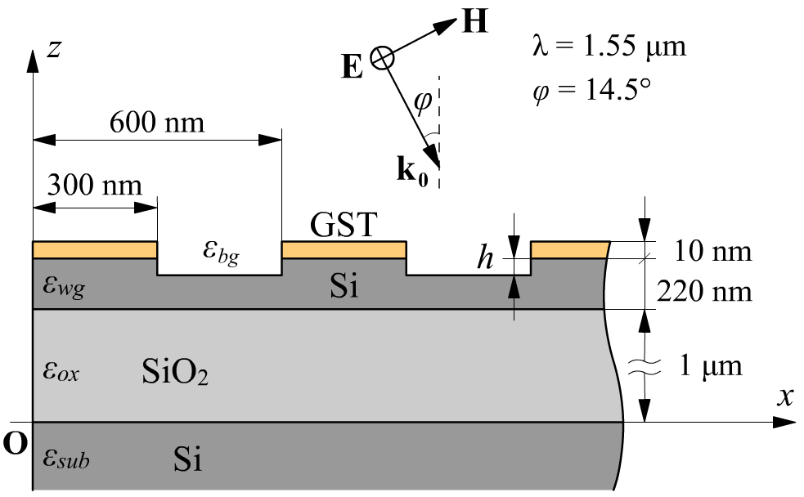 | 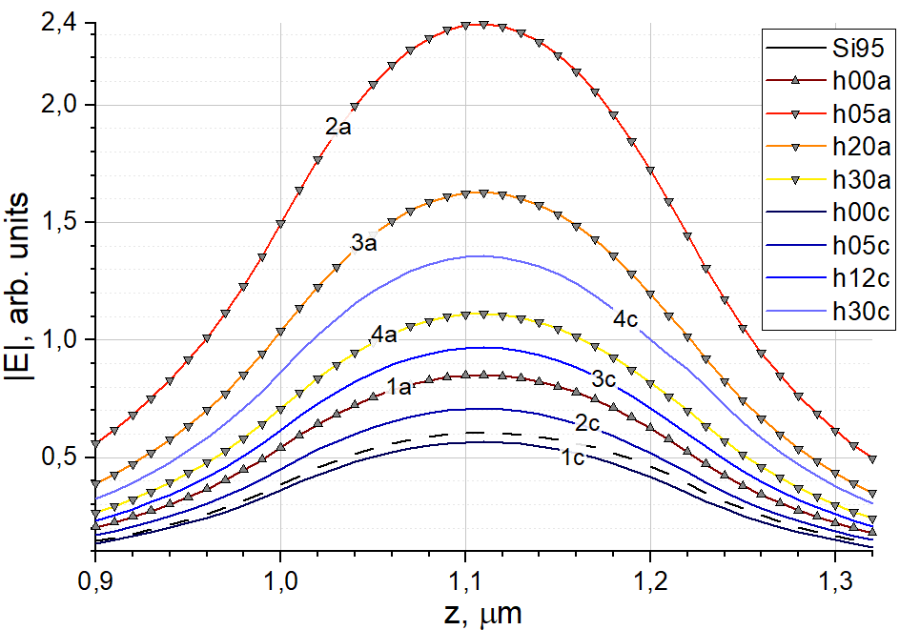
Figure 1. (a) Considered structure – composite GST+SOI diffraction grating; (b) excited mode profiles without additional silicon etching (lines 1a,c) and with etching to depths 5 nm (2a,c), 20 and 12 nm (3a,c), 30 nm (4a,c).

This study was supported by the Russian Foundation for Basic Research, project No.19-29-03040.

REFERENCES
[1] G. Ya. Krasnikov, N. A. Zaitcev, Nano and Microsystem Technique, 1, 2 (2009) (in Russian)
[2] M. Wuttig, H. Bhaskaran, T. Taubner, Nature Photonics, 11, 465 (2017)
[3] J. Wang, L. Wang, J. Liu, IEEE Access, 8, 121211 (2020)
[4] R. T. Minnullin et al., IOP Conf. Ser.: Mater. Sci. Eng., 840, 012008 (2020)

