Label-free Third Harmonic Generation Imaging of Lipid Droplets in Live Filamentous Fungi

T. Pajić¹, N. Todorović², M. Zivić¹, M. Rabasović³, A.H.A. Clayton⁴, and A. Krmpot³
¹University of Belgrade – Faculty of Biology, Belgrade, Serbia
²Institute for Biological Research “Siniša Stanković”, University of Belgrade, Serbia
³Institute of Physics, Belgrade, Serbia
⁴Optical Sciences Centre, Swinburne University of Technology, Victoria, Australia
e-mail:tpajic@bio.bg.ac.rs

Oleaginous fungi can accumulate significant amounts of lipids in their mycelium (up to 80% of their biomass), primarily in the form of lipid droplets (LDs). LDs have optical properties that differ from the surrounding aquatic environment, which causes sudden changes in the refractive index. Here, we present in vivo and label-free imaging of individual hyphae of the oleaginous filamentous fungus Phycomyces blakesleeanus by Third Harmonic Generation (THG) microscopy method [1], where LDs are the main source of contrast [2] (Figure 1). The LDs quantification from THG images was performed by two image analysis techniques: Image Correlation Spectroscopy (ICS) and software particle counting – Particle Size Analysis (PSA). ICS measures the spatial variation of fluorescence intensity fluctuations in the images, which can then be related to particle density and aggregation state. In order to test and compare the two methods, we used hyphae that undergo nitrogen starvation, which is known to cause alterations in lipid metabolism and the increase in LDs number.
For in vivo THG imaging of label-free, > 24-hour old hyphae, we used 1040 nm, 200 fs pulses from Yb KGW laser. Detection was performed in the transmission arm by PMT through Hoya glass UV filter with peak transmission at 340nm. The laser beam was focused with the Zeiss Plan Neofluar 40x1.3 objective lens. For the imaging, the fungi were placed between two cover glasses of 0.17 μm thickness to match the objective lens requirements and for better transmission of the THG signal.

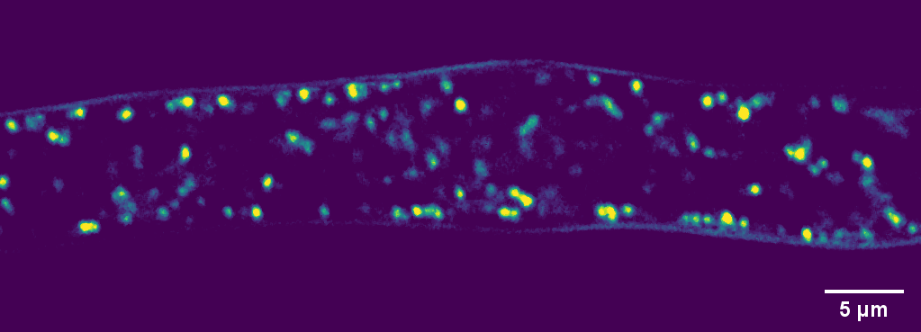

Figure 1. THG image of lipid droplets in hyphae of the fungus Phycomyces blakesleeanus. The bright objects are lipid droplets.

An increased number of LDs under nitrogen starvation was observed in THG images and their number and size were analyzed using two quantification methods. The comparison of LDs number and size obtained by ICS and PSA shows that the number of LDs is approximately the same on average, but that ICS consistently detects slightly larger LD number in older group. The mean ICS measured diameter was slightly lower. Using the THG method in vivo and label-free, we can accurately and reliably, over time, detect changes in the localization, total number, and size of LDs in hyphae of the oleaginous filamentous fungus Phycomyces blakesleeanus.

Acknowledgement: Project HEMMAGINERO, No. 6066079 from Program PROMIS, Science Fund of the Republic of Serbia, and Project „Minimally invasive, selective ablation of dental caries by
femtosecond laser “Move for the science/2019

REFERENCES
[1] R. W. Boyd, Academic Press (2008).
[2] D. Débarre, W. Supatto, A. M. Pena, A. Fabre, T. Tordjmann, L. Combettes, E. Beaurepaire, Nature Methods, 3(1), 47–53. (2006).

