Compact, commercial 200 kHz few-cycle OPCPA
at 800 nm with stable CEP

Ekaterina Zapolnova¹, Thomas Braatz¹, Sebastian Starosielec¹,
Torsten Golz¹, Mark J. Prandolini^{1,2}, Jan Heye Buss¹, Michael Schulz¹, and Robert Riedel¹
¹Class 5 Photonics GmbH, Notkestraße 85, 22607 Hamburg, Germany
²Institut für Experimentalphysik, Universität Hamburg, Luruper Chaussee 149, 22761 Hamburg, Germany
e-mail: robert.riedel@class5photonics.com

For attosecond technology, carrier envelope phase (CEP) stabilization in the few-cycle regime combined with high repetition rates is essential for studying ultrafast electronic processes in atoms, molecules, solids, and complex many body systems [1-3]. Therefore, a laser system was designed, where the laser pulses are generated from a single white-light generation (WLG) source operating at 200 kHz, providing CEP stable pulses at 800 nm with pulse durations of < 10 fs, and pulse energies of 15 𝜇J. A passive CEP jitter over 10 min was measured with an f-to-2f interferometer below 170 mrad rms.
Additionally, a second output is optionally available providing simultaneously CEP stable pulses at 2 µm which allows for pump-probe measurements.
The system is robust and compact, with a footprint of less than a square meter, and commercially available from Class 5 Photonics GmbH.

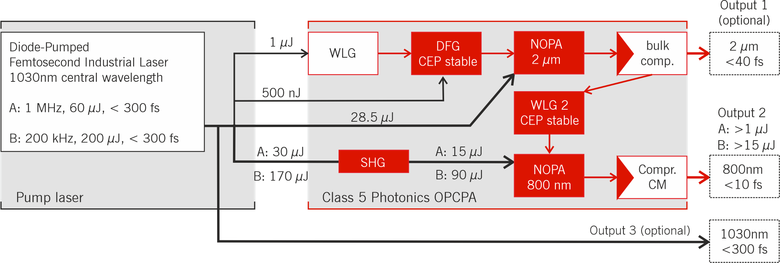

Figure 1. Schematic of the laser system with white-light generation (WLG), second-harmonic generation (SHG), non-colinear optical-parametric chirped-pulse amplifier (NOPA), chirped-mirror (CM) compressor.

REFERENCES
[1] Calegari, F., et-al. “Ultrafast electron dynamics in phenylalanine initiated by attosecond pulses”, Science, 336-339 (2014)
[2] Uzan, A.J, et al. “Attosecond spectral singularities in solid-state high-harmonic generation.”, Nat. Photonics 14, 183–187 (2020).
[3] Harth, A., et.-al. “Compact 200 kHz HHG source driven by a few-cycle OPCPA”, Journal of Optics 20, 014007 (2017)

