Fibonacci sequence design for MXene based metasurface with enhanced optical absorption in the visible range

M. Obradov, Z. Jakšić, D.Tanasković, I. Mladenović, D. Vasiljević Radović
Centre of Microelectronic Technologies, Institute of Chemistry, Technology and Metallurgy - National Institute of the Republic of Serbia
University of Belgrade, Njegoseva 12, 11000 Belgrade, Serbia
e-mail:marko.obradov@nanosys.ihtm.bg.ac.rs

In this contribution we aim to extend the use of fractal sequences in broadband Bragg grating superabsorbers to ultrathin metasurface-based superabsorbers utilizing plasmonic effects.
Bragg gratings in our case represent 1D metamaterials with their dispersive properties tailored by the thickness and the number of the grating lines. Additional tailoring of optical properties for broadband applications can be achieved by embedding in-plane truncated sequences of various infinite series, i.e. Cantor or Fibonacci sequences, to form quasi periodic fractal metasurfaces. These structures are further optimized towards enhanced optical absorption by utilizing various conductive materials. Here, we utilize MXenes as a class 2D materials characterized by free-electron conductivity instead of more commonly utilized plasmonic materials like noble metals or graphene .
An alternative approach to the superabsorber design is to utilize two thin conductive sheets separated by a thin dielectric layer. By structuring one of the conductive layers as a 1D diffraction grating the incident light couples with the plasmonic modes that are localized within the dielectric layer, thus achieving enhanced optical absorption on the subwavelength level .
We theoretically and numerically analyze a metamaterial absorber structure consisting of thin MXene (titanium carbide) strips as presented in Fig.1.a. The top layer is patterned by thin strips of MXene separated by narrow air gaps. Both narrow gap and MXene strip widths follow the Fibonacci sequence starting with 10 nm. The middle layer is silica glass, and bottom layer is a thin MXene sheet. Fig.1.b presents widening of useful absorption spectra by increasing the number of embedded sequence elements. We believe our proposal extends the toolbox for the design of plasmonic metamaterial-based superabsorbers, but one could also envision its use for other applications.

a) | 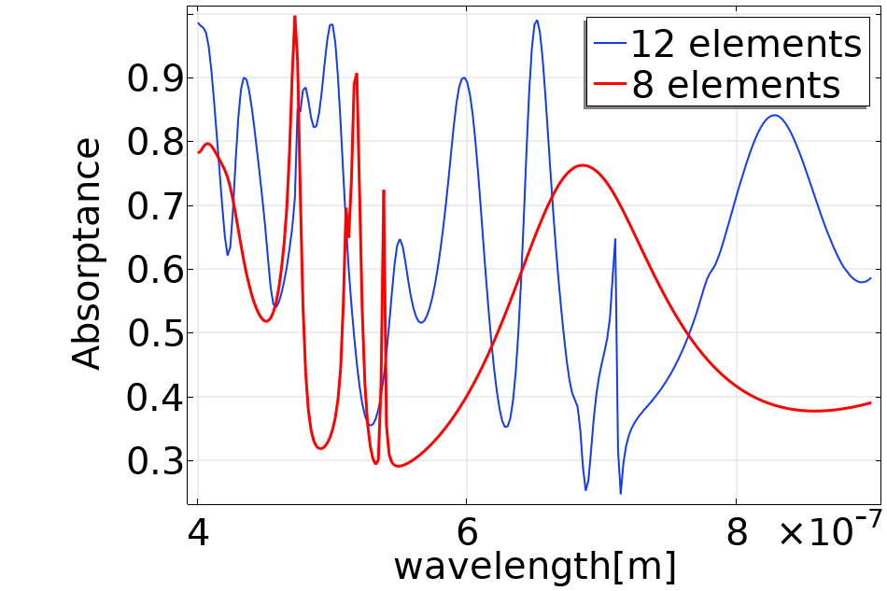  b)
Figure 1. MXene metamaterial with striped top surface. a) unit cell consisting of strips and gaps whose widths are following a finite Fibonacci sequence.(numbers given in the picture represent widths of the elements in nm). Thickness of each layer is 50 nm. b) Absorption spectra depending on the order of the Fibonacci sequence.
REFERENCES

[1] R. Ning, S. Liu, H. Zhang, X. Kong, B. Bian, J. Bao, J. Opt., 16(12), 125108, 2014.
[2] M. Maksimović, Z. Jakšić, J. Opt. A-Pure Appl. Opt., 8(3), 355-362, 2006.
[3] Z. Jakšić, M. Obradov, D. Tanasković, O. Jakšić, D. V. Radović, Opt. Quant. Electron.,52(2), 1-10, 2020.
[4] K. Aydin, V. E. Ferry, R. M. Briggs, and H. A. Atwater, Nature Comm., 2, 517, 2011.

