An estimation of the far-field intensity distribution for novel hollow photonic crystal optical fibers

M. S. Kovačević¹, Lj. Kuzmanović¹, M. M. Milošević¹ and A. Djordjevich²
¹Faculty of Science, University of Kragujevac, Serbia
²City University of Hong Kong, Hong Kong
e-mail: kovac@kg.ac.rs

In this paper, the far-field intensity distribution of hollow photonic crystal optical fibers (HPCF) is thoroughly analyzed using an analytical approach based on the normalized frequency (V parameter) and normalized attenuation constant (W parameter). Utilizing a three-layered structure of HPCF with a central air hole, the characteristic M-shaped index profile is obtained by forming a silica ring core with its own value of the effective index corresponding to the distinct size and/or spacing of air holes in it. By altering the hole-to-hole spacing () and hole diameter () in the selected fiber layer, the effective index profile can be adjusted for the cladding region. Using the empirical relations for the V and W parameters of photonic crystal fibers (PCF), the dependence of the far-field intensity distribution on two structural parameters - the air hole diameter and the air hole pitch is calculated and presented. The results displayed here can find their utilization in the design and development of a sensor system based on HPCFs for potential application involving structural health monitoring, medicine, environmental monitoring sensors, multimode fiber (MMF) mode convertor for gigabit LAN, higher-order-mode (HOM) dispersion compensation, tunable bandpass filters, etc.

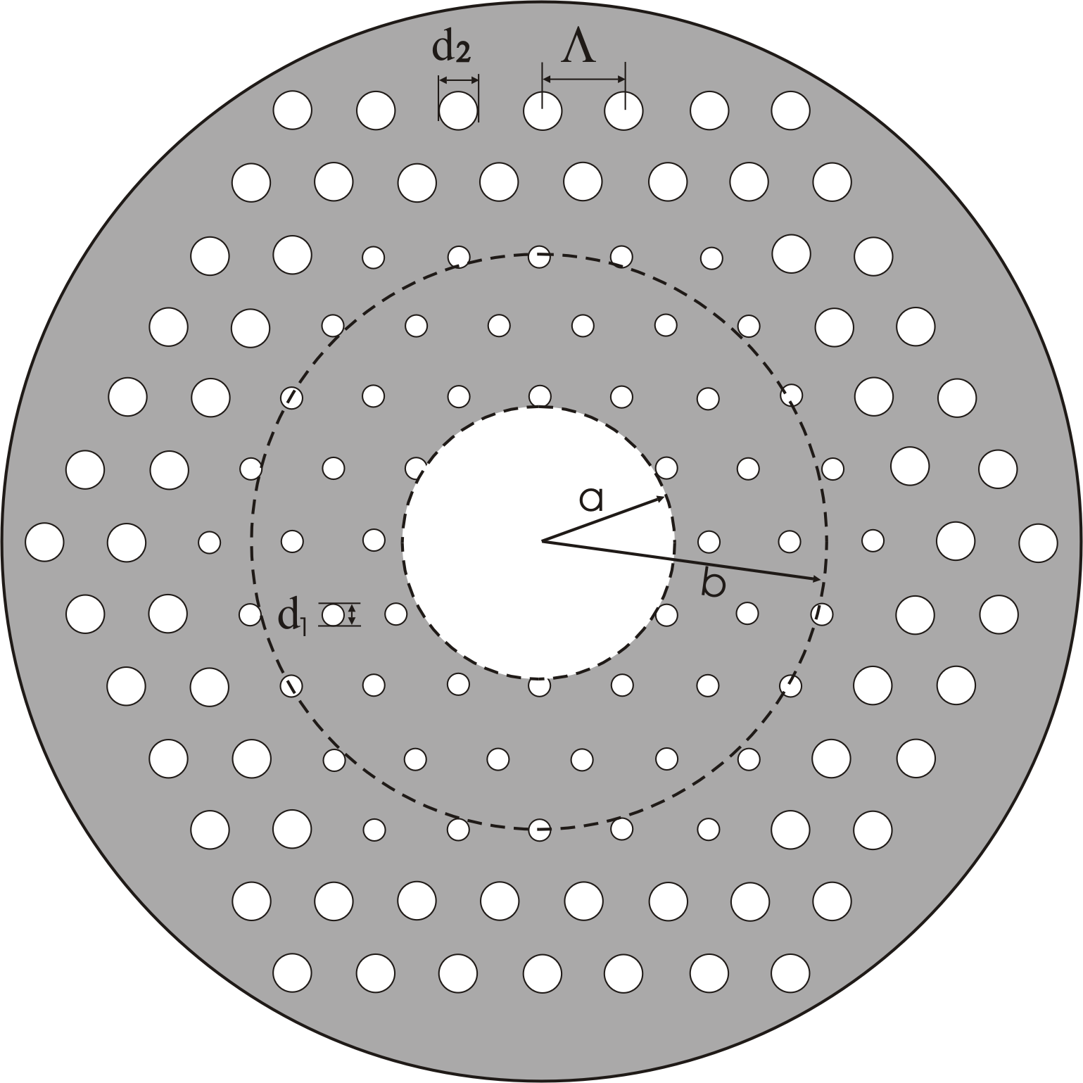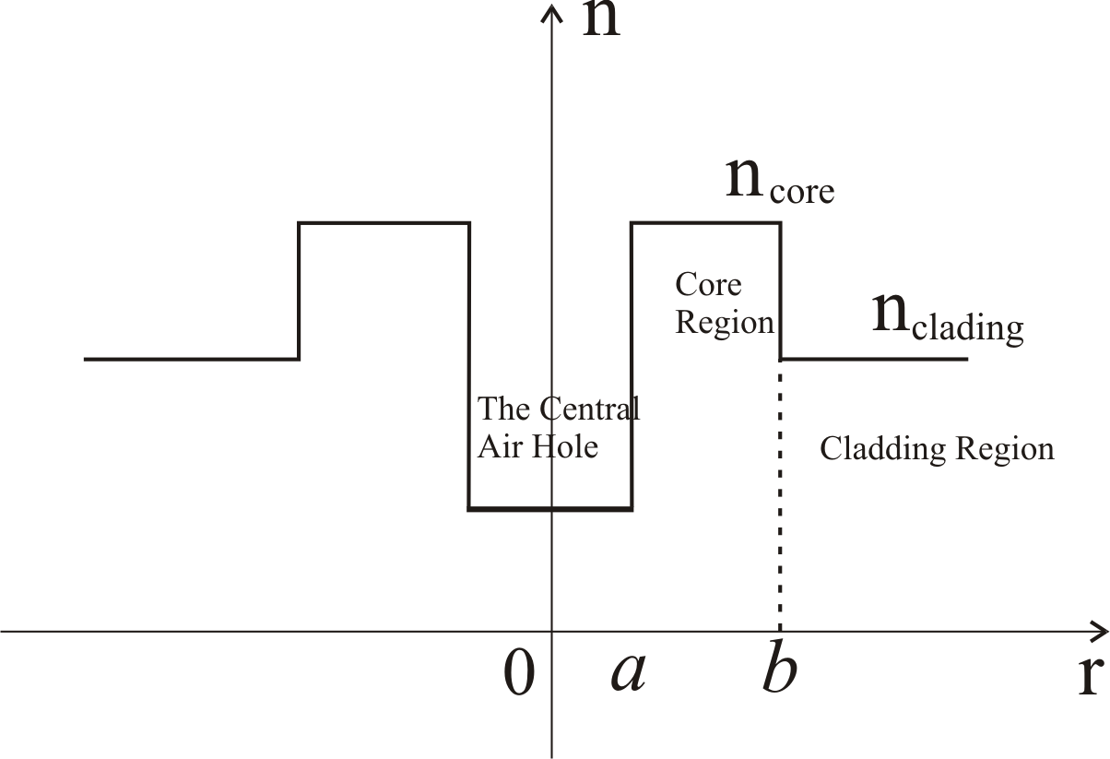
(a) (b)
Figure 1. (a) Cross section of a three-layered structure of M-type PCF (central air hole, ring core region and cladding region); (b) refractive index profile of the referent M-type PCF.
REFERENCES
[1] S. Lee, J. Park, Y. Jeong, H. Jung, and Kyunghwan Oh, J. Light. Technol. 27 (22), 4019 (2009).
[2] Kyunghwan Oh, J. Light. Technol. 23 (2), 524 (2005).
[3] P. St. J. Russell, Science 299, 358 (2003).
[4] J. C. Knight, Nature 424 (14), 847 (2003).
[5] Knight J. C., J. Broeng, T. A. Birks, and P. S. J. Russell, Science 282, 1476 (1998).
[6] Knight J. C. and P. S. J. Russell, Science 296 (2002).
[7] M. S. Kovačević, L. Kuzmanović, A. Simović, S. Savović, and A. Djordjevich, J. Light. Technol. 35 (20), 4352 (2017).
[8] M. S. Kovačević, Lj. Kuzmanović, A. Simović, S. Savović, B. Drljača, A. Djordjevich, Opt. Commun. 427, 348 (2018).
[9] K. Saitoh and M. Koshiba, Opt. Exp.13, 267 (2005).

