Femtosecond laser spectroscopy for Exploration of Space:
Introduction of new research group at German Aerospace Center

N. Stojanovic¹, M. Gensch^{1,2}
¹ Institut für Optische Sensorsysteme, DLR, Berlin, Germany
² Technische Universität Berlin, Berlin, Germany.

e-mail: nikola.stojanovic@dlr.de

The Time-Domain Spectroscopy group (TLS - ZS) in the department of Terahertz and Laser Spectroscopy (TLS) has a long track record in instrumentation development and has in recent years pioneered terahertz time-domain set-ups demonstrating world-wide unique sensitivity levels [1,2]. It is currently working on developing compact laser-based spectroscopy techniques based on short-pulse lasers for future applications in e. g. robotic missions to extraterrestrial objects in our solar system. Scientific applications range from planetary research to nonlinear spectroscopy of novel quantum materials with applications in space instruments (e. g. topological insulators or Graphene[3]). The group is furthermore contributing its expertise in laser spectroscopy, optic design, detector development and qualification of spectroscopy components to different cross-sectoral projects within TLS.
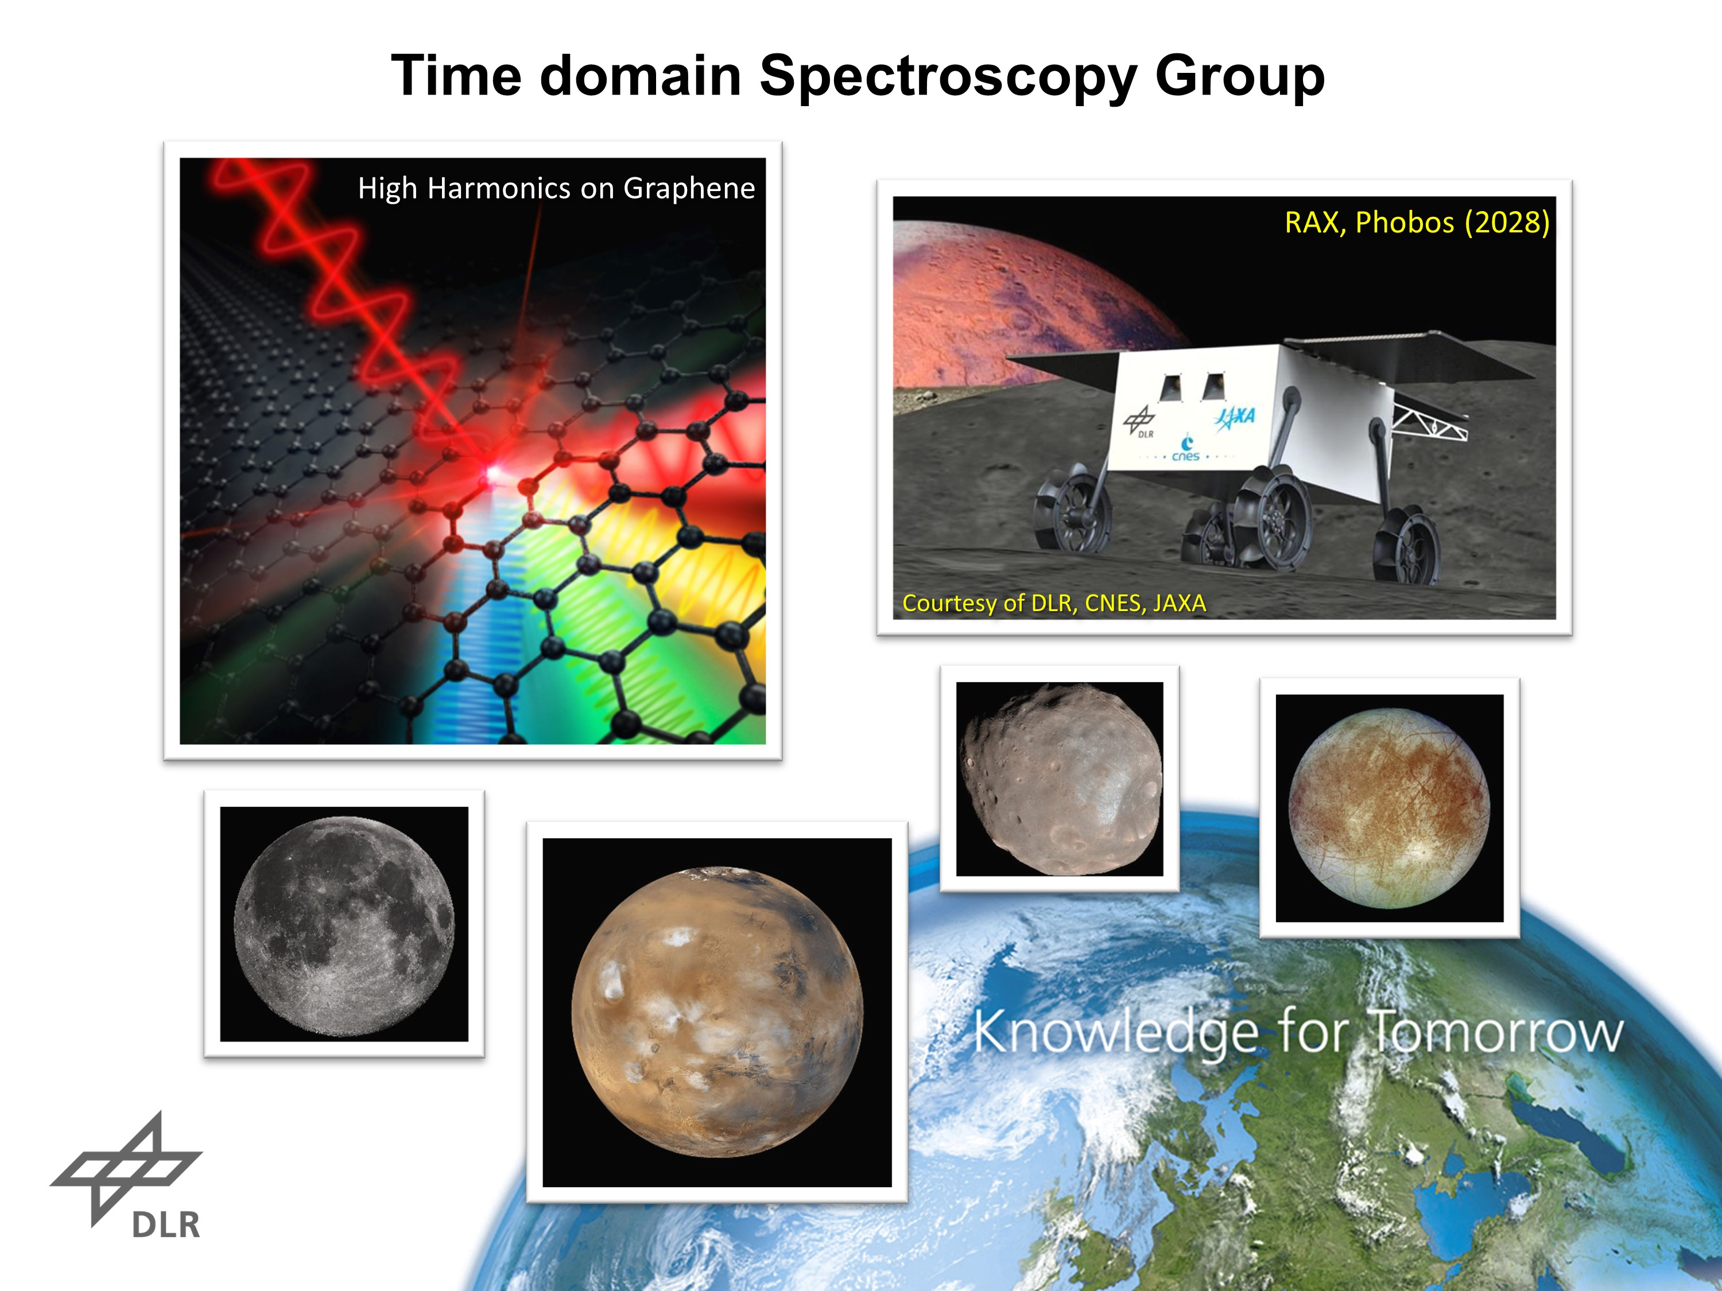

Figure 1. Towards new research enabled by space ready ultrafast lasers

REFERENCES
- R. Pan, et. al. J. Synchrotron Radiat. 26 (3) (2019) 700–707.
- B. Green, et. al., Sci. Rep. 6, 22256 (2016).
- H. A. Hafez et. al., Nature, 561, 507 (2018)

