Faraday and Resonant Waves in Dipolar Cigar-Shaped
Bose-Einstein Condensates

Dušan Vudragović
Scientific Computing Laboratory, Center for the Study of Complex Systems,
Institute of Physics Belgrade, University of Belgrade, Serbia
e-mail:dusan@ipb.ac.rs

Faraday and resonant density waves emerge in Bose-Einstein condensates as a result of harmonic driving of the system [1-3]. They represent nonlinear excitations and are generated due to the interaction-induced coupling of collective oscillation modes and the existence of parametric resonances. Using a mean-field variational and a full numerical approach, we study density waves in dipolar condensates at zero temperature [1], where breaking of the symmetry due to anisotropy of the dipole-dipole interaction plays an important role. We derive variational equations of motion for the dynamics of a driven dipolar system and identify the most unstable modes that correspond to the Faraday and resonant waves. Based on this, we also derive the analytical expressions for spatial periods of both types of density waves as functions of the contact and the dipole-dipole interaction strength. Finally, we compare the obtained variational results with the results of extensive numerical simulations that solve the dipolar Gross-Pitaevskii equation in 3D.

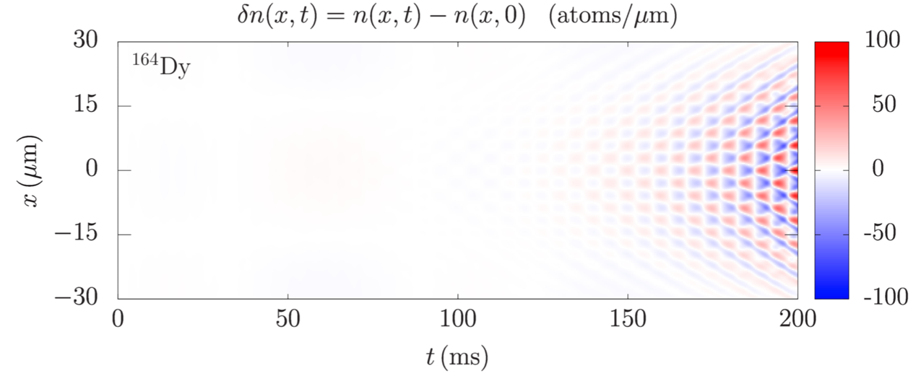
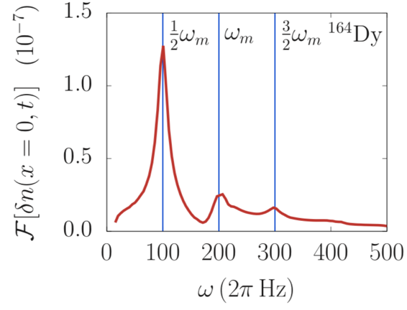

REFERENCES
[1] D. Vudragović and A. Balaž, Symmetry 11, 1090 (2019).
[2] A. Balaž, R. Paun, A. I. Nicolin, et al., Phys. Rev. A 89, 023609 (2014).
[3] A. Balaž and A. I. Nicolin, Phys. Rev. A 85, 023613 (2012).

