Approaching the Heisenberg limit in a many-spin system

S. Colombo¹, E. Pedrozo-Peñafiel¹, A. Adyatullin¹, Z. Li¹, E. Mendez¹, C. Shu^{1,2}, V. Vuletić¹
¹Department of Physics, MIT-Harvard Center for Ultracold Atom sand Research Laboratory of Electronics, Massachusetts Institute of Technology, Cambridge, MA, United States of America
²Department of Physics, Harvard University, Cambridge, MA, United States of America
e-mail:colombos@mit.edu

A long-sought in the field of Quantum Metrology is the creation of exotic quantum states that allow atomic sensors to operate far beyond the Standard Quantum Limit (SQL), where the precision scales with square root of the number of involved particles N1/2. Gaussian Spin Squeezed States have been used to overcome the SQL in atomic sensors but offer limited quantum metrological advantages. To approach the Heisenberg Limit, Non-Gaussian Entangled States (NGES) that carry larger statistical information have to be engineered. However, the fragility of highly entangled states against decoherence and single-particle state resolution requirements have made difficult their experimental realization and application to atomic sensors with today’s technology.
We present here the implementation of a robust Signal Amplification through Time-reversal INteraction (SATIN) protocol that allows for the generation of NGESs and the efficient use of their quantum resource. In particular, we report the largest sensitivity improvement beyond the SQL demonstrated in any interferometer to date [2]. This is achieved by experimentally demonstrating for the first time a previously proposed effective time-reversal protocol [1], where a NGES is generated through a nonlinear Hamiltonian. When this state is subjected to a small signal (phase shift), the application of the negative nonlinear Hamiltonian (“time reversal”) generates a large amplification of the interferometric signal that can be read out easily.
Our work presents a new paradigm of nonlinear atomic sensors where the time-reversal protocol enables robust operation far beyond the SQL, and close to the Heisenberg limit with precision improving in proportion to atom number. Potential applications include searches for dark matter and for physics beyond the standard model, tests of the fundamental laws of physics, timekeeping, and geodesy.
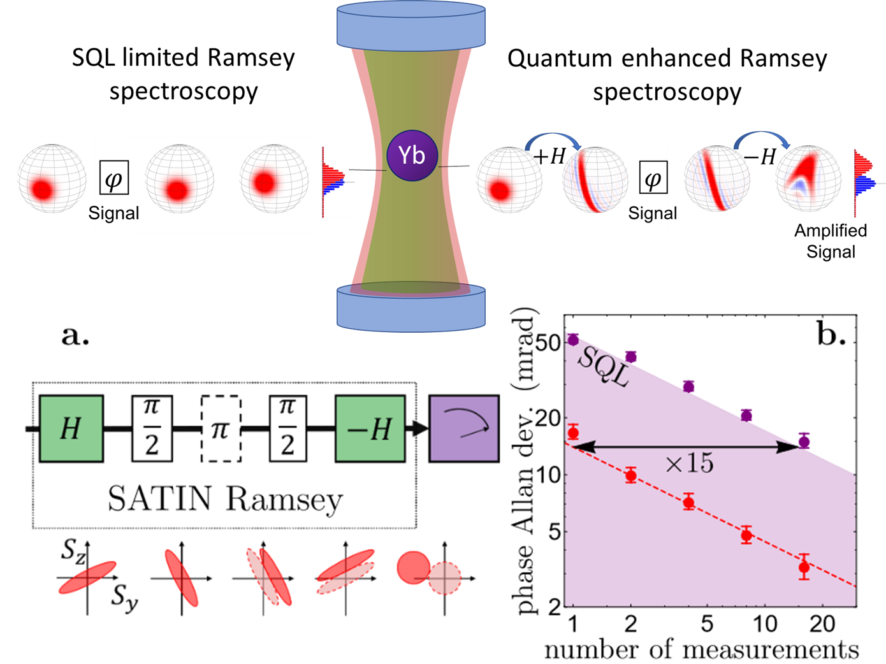

Figure 1. SATIN protocol principle and its application to Ramsey spectroscopy.
REFERENCES
[1] E. Davis, G. Bentsen, Schleier-Smith, Phys. Rev. Lett. 116(5), 053601 (2016).
[2] S. Colombo, E. Pedrozo-Peñafiel, et. al., arXiv:2106.03754 (2021).

