Autler-Townes spectroscopy in a Mn-doped InGaAs/GaAs quantum dot

J. Filipovic, A. Lemaître and O. Krebs
¹Centre for Nanosciences and Nanotechnology, CNRS, University Paris-Saclay, France
e-mail: jovana.filipovic@universite-paris-saclay.fr

For more than a decade, doping of semiconductor quantum dots (QDs) with a single magnetic atom has provided the unique possibility to investigate exchange interaction in the quantum regime [1,2] and to manipulate the corresponding spin states with light [3, 4]. In particular, the optical Stark effect induced by a strong optical excitation was demonstrated in II–VI QDs [4]. Here, we investigate similar effects in a self-assembled InGaAs/GaAs QD doped with a single Mn atom. This point defect in a III-V matrix forms a neutral acceptor A⁰ with a spin=1 [2]. In our present experiment, it is further coupled to a resident single hole giving rise to ferromagnetic (FM) and antiferromagnetic (AFM) levels split by about 1 meV. Under inter-band optical excitation, the QD exhibits thus a specific scheme of transitions consisting in a double lambda-system (Fig.1a). A continuous-wave (cw) tunable laser can be used to drive successively two transitions from the FM ground state, whereas the excited populations are directly monitored via the micro-photoluminescence (μPL) towards the AFM level (Fig.1b). In this sample, the observed resonance linewidths are dominated by spectral diffusion (~20 µeV) and does not reveal the QD natural linewidth (~1.5 µeV). Still, optical Stark shift was clearly observed, and far above the saturation regime, an Autler-Townes splitting was spectrally resolved with the expected $∝\sqrt{P}$ power dependence. More interestingly, by driving the system with a weak probe laser at resonance with the upper transition, while a stronger pump laser is scanned through the lower transition (Fig.1c), it is possible to spectrally resolve the Autler-Townes effect experienced by the FM ground state, much below the spectral diffusion broadening limit. In this regime, the probe signal shows a Lorentzian dip with typical 10 µeV spectral width, near the pump laser resonance (Fig.1d). This is a signature of the Autler-Townes effect in the ground state, which moreover reveals that the spin coherence of the two excited states is essentially unaffected by the spectral diffusion.
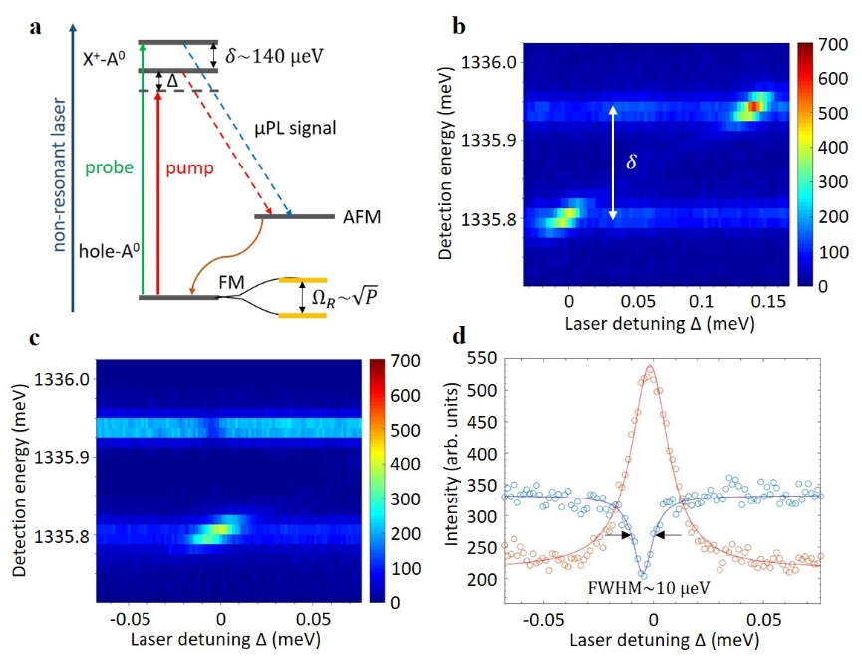
Figure 1. a) Energy levels of single positively charged Mn-doped QD driven by probe and pump cw lasers. Under strong resonant driving, dressed states are indicated (orange) for the ground state with Rabi frequency Ω_{R}. b) μPL spectra against detuning of a single scanning laser (P=16 μW). c) μPL spectra for a fix resonant probe laser (P=1.3 μW) and a scanning pump laser (P=11 μW). d) Intensities of the two transitions extracted from c (circles) fit with Lorentzian curves (solid lines).

REFERENCES
[1] L. Besombes, et al., Phys. Rev. Lett. 93, 207403 (2004).
[2] A. Kudelski, et al., Phys. Rev. Lett. 99, 247209 (2007).
[3] E. Baudin, et al., Phys. Rev. Lett. 107, 197402 (2011).
[4] C. Le Gall et al., Phys. Rev Lett. 107, 057401 (2011).

