Using SOLO software package for classification of temperature dependent luminescence spectra

D. Sevic¹, M.S. Rabasovic¹, J. Krizan², S. Savic-Sevic¹, M.D. Rabasovic¹, M.G. Nikolic¹
and B.P. Marinkovic¹
¹Institute of Physics, Belgrade, Serbia
²AMI d.o.o., Ptuj, Slovenia
e-mail:sevic@ipb.ac.rs

In this study we use SOLO software package (Version 8.8, Eigenvector Research Inc, USA) for classification of temperature dependent luminescence spectra of nanocrystalline Gd₂O₃ doped with Er and Yb. Material was synthesized by combustion method, as described in [1]. Our experimental setup is presented in detail in [2,3]. In [4,5] we have used Principal Component Analysis of luminescence spectra of thermophosphors; here, we use classification tools based on more sophisticated K-Nearest Neighbor and K-Means Nearest Group algorithms.

Classification results (shown as dendrograms) of luminescence spectra of Gd₂O₃:Er³⁺,Yb³⁺ at different temperatures using K-Nearest Neighbor and K-Means Nearest Group algorithms are shown in Figure 1. Although dendrograms are different, the groups determined by both methods are the same; moreover, the test luminescence spectra are also classified in temperature groups where they belong. So, the machine could be trained to differentiate spectral data obtained on different temperatures.

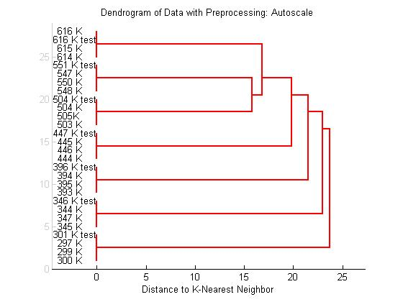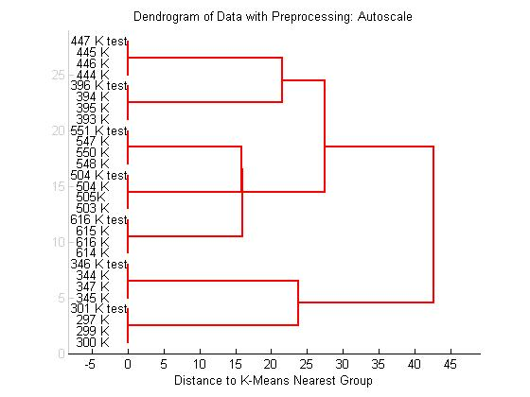
(a) (b)
Figure 1. Classification results (shown as dendrograms) of luminescence spectra of Gd₂O₃:Er³⁺,Yb³⁺ at different temperatures using (a) K-Nearest Neighbor and (b) K-Means Nearest Group algorithms.
REFERENCES
[1] J. Krizan, M. Mazaj, V. Kaucic, I. Bajsic, J. Mozina, Acta Chim. Slov. 61, 608 (2014).
[2] D. Sevic, M.S. Rabasovic, J. Krizan, S. Savic-Sevic, M.D. Rabasovic, B.P. Marinkovic,
M.G. Nikolic, Optical and Quantum Electronics 52, 232 (2020).
[3] D. Sevic, M.S. Rabasovic, J. Krizan, S. Savic-Sevic, M.G. Nikolic, B.P. Marinkovic, M.D. Rabasovic, J. Phys. D: Appl. Phys. 53, 015106 (2020).
[4] D. Sevic, A. Vlasic, M.S. Rabasović, S. Savic-Sevic, M.D. Rabasović, M.G. Nikolić, B. D. Muric, B. P. Marinković, J. Križan, Tehnika 75(3), 279 (2020).
[5] D. Sevic, J. Krizan, M. S. Rabasovic, B.P. Marinkovic, Eur. Phys. J. D 75, 56 (2021).

