High-resolution terahertz and infrared spectroscopy of hybrid perovskite CH₃NH₃PbI₃

V. Anikeeva^{1,2}, K. Boldyrev¹, O. Semenova³, and M. Popova¹
¹Institute of Spectroscopy of the Russian Academy of Sciences, Troitsk, Moscow, Russia
²National Research University Higher School of Economics, Moscow, Russia
³Rzhanov Institute of Semiconductor Physics of the Siberian Brunch of the Russian Academy of Sciences, Novosibirsk, Russia
e-mail: vanikeeva@hse.ru

The hybrid metal-organic perovskite CH₃NH₃PbI₃ belongs to a class of semiconductor compounds with the crystal structure ABX₃, where A = CH₃NH₃⁺, NH₂CH=NH₂; B = Pb, Sn; X = I, Br, Cl. This class of compounds has useful physical properties such as high values of the absorption coefficient, a high carrier mobility, large diffusion lengths, and optical properties optimal for the photovoltaics, making them perspective materials for photodetectors, lasers, LEDs, and thermoelectric devices and especially as transport or/and absorber layers in solar cells [1].
Notwithstanding a large number of studies of optical properties of hybrid perovskites, most of them were carried out on thin films. In this work, high quality large single crystals of methyl ammonia lead iodide (CH₃NH₃PbI₃) were investigated by high-resolution (up to 0.2 cm⁻¹) spectroscopy in the wide spectral (15 – 650 cm⁻¹, 1750 – 12000 cm⁻¹) and temperature (5 – 330 K) ranges. The CH₃NH₃PbI₃ single crystals were grown from a saturated solution by the method described in [2]. We observed several low-frequency modes and a torsional mode of molecular cation at 306 cm⁻¹, which were not previously reported (Figure 1).
Furthermore, an unusual behavior of the transmission spectra was observed across the temperature of the phase transition from an orthorhombic to a tetragonal phase (~160 K) and when a crystal was cooled down to 70 K. An observed splitting of the spectral line at 2592 cm⁻¹ was attributed to the tunneling dynamics of molecular cation CH₃NH₃⁺ [3].

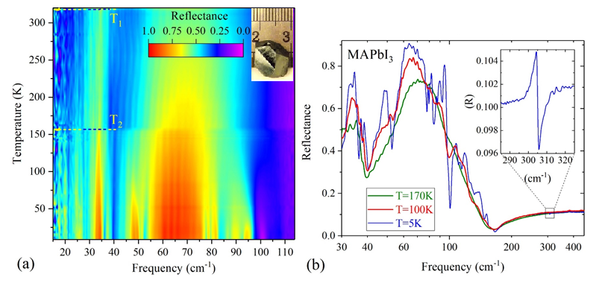
Figure 1. CH₃NH₃PbI₃ reflectance spectra. (a) A map of the reflectance intensity as a function of the frequency and the temperature and (b) single spectra at 5, 100, and 170 K; an enlarged part of the lowest temperature spectrum represents a torsional mode at 306 cm⁻¹. The insert in the panel (a) depicts a photo of the investigated single crystal.
This work was supported the Russian Science Foundation (Grant No.19-72-10132).

REFERENCES
[1] T. Brenner, D. Egger, L. Kronik, G. Hodes, D. Cahen, Nat. Rev. Mater. 1, 15007 (2016).
[2] O. Semenova, E. Yudanova, N. Yeryukov, Y. Zhivodkov, T. Shamirzaev, E. Maximovskiy, S. Gromilov, I. Troitskaia, J. Cryst. Growth 462, 45 (2017).
[3] K. Boldyrev, V. Anikeeva, O. Semenova, M. Popova, J. Phys. Chem. C, 124, 42, 23307 (2020).

