Control of entanglement between driven three-level atom in ladder-type configuration and its spontaneous emission

Lj. Stevanović and N. Andrejić
Department of Physics, Faculty of Sciences and Mathematics, University of Niš, Serbia
e-mail:ljstevanovic@junis.ni.ac.rs

Investigation of atom – photon entanglement attracts the attention in the past decades due to its application in the areas of quantum communication and quantum computing [1]. The numerous papers, dealing with that subject, are devoted to entanglement between the atom and its spontaneous emission. The study is based on the model of multi-level atom in different configurations dressed by coherent field [2], [3].

Here, we study the entanglement between the three-level atom and its spontaneous emission. The atom is driven by two coherent laser fields: one field induces transition between the ground and the first excited level, while the other field induces transition between the excited levels, making the ladder-type configuration. The optical Bloch equations, describing the density matrix evolution, are derived in semiclassical approach under rotating wave approximation and then solved numerically in the steady-state regime. Reduced entropy, based on atomic density matrix, is used as the measure of entanglement.

The effect of the system parameters, like spontaneous decay rates of the excited levels, Rabi frequencies and detunings of the laser fields, on entanglement is investigated in details. The influence of Rabi frequencies is studied in two cases: when one of them is much less then the other and when they are comparable. Also, the effect of detunings is considered in the case of two-photon resonance and beyond it. Another way in investigation is devoted to the control of entanglement by the vacuum induced coherence, which is achieved in the quantum system with equidistant levels.

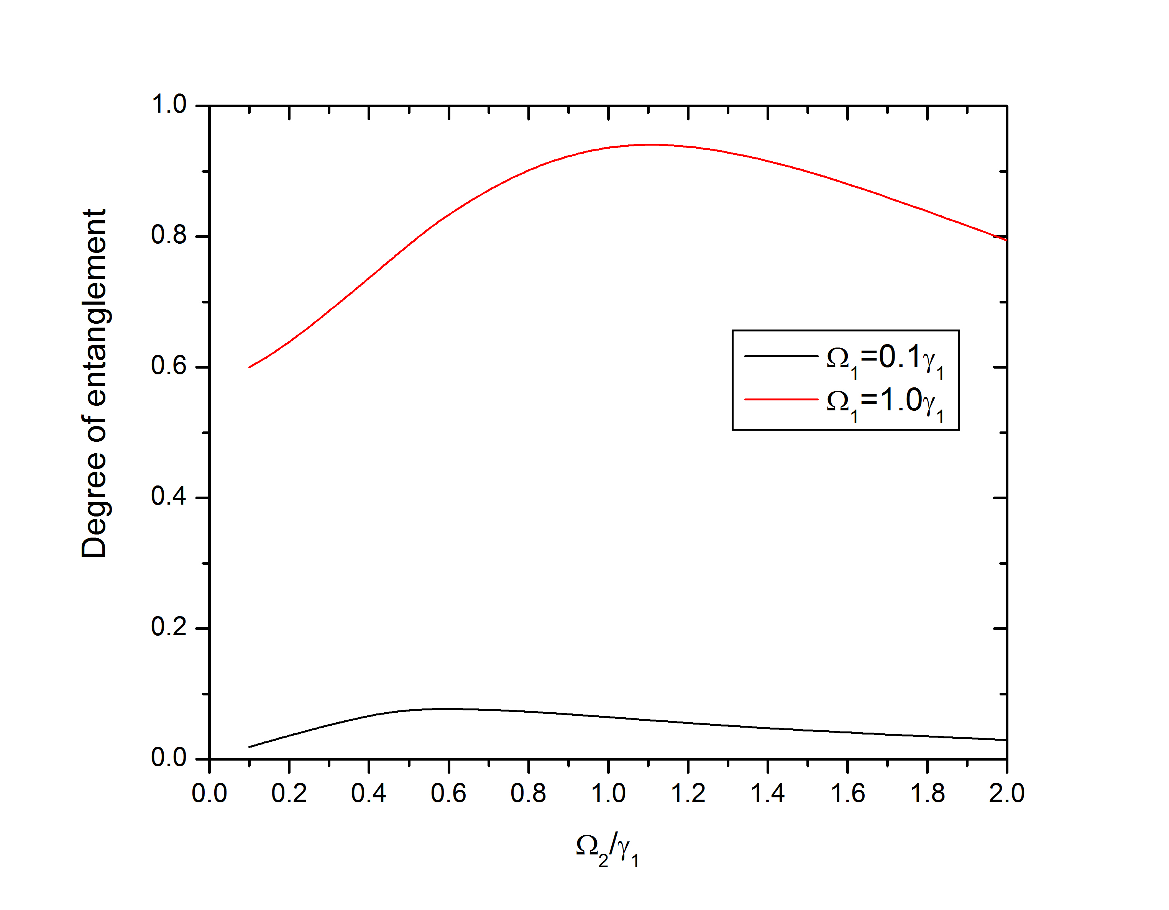
Figure 1. Effect of Rabi frequencies of the laser fields on the degree of entanglement.

REFERENCES
[1] S. Chen, Y. A. Chen, B. Zhao, Z. S. Yuan, J. Schmiedmayer, J. W. Pan, Phys. Rev. Lett. 99, 180505 (2007).
[2] A. Mortezapour, M. Abedi, M. Mahmoudi, M. R. H. Khajehpor, J. Phys. B: At. Mol. Opt. Phys. 44, 085501 (2011)
[3] Z. Kordi, S. Ghanbari, M. Mahmoudi, Quant. Inf. Process 15, 199 (2016)

