Quantum droplets in dipolar ring-shaped Bose-Einstein condensates

M. Šindik¹, A. Pelster² and A. Balaž¹
¹Institute of Physics Belgrade, University of Belgrade, Serbia
²Department of Physics, Technical University of Kaiserslautern, Germany
e-mail: marijas@ipb.ac.rs

We study the formation of quantum droplets in dipolar Bose-Einstein condensates in a ring-shaped geometry using numerical techniques. A condensate is initially prepared in a stable ground state of the system, and droplet formation is triggered by a sudden quench of the contact interaction. We investigate how the number of the obtained droplets depend on the total number of atoms in the system, as well as on the strength of the contact and the dipole-dipole interaction. These results can be used in experiments to fine-tune parameters of the system in order to produce droplets of desired size. Furthermore, we study the emergence of supersolidity in the system, when droplets are formed due to the contact interaction quench, but the common phase is still preserved among spatially separated droplets. The quasi-1D geometry imposes additional constraints in the system, in particular when the particle density is higher, such that quantum fluctuation effects become more prominent. We use the Bogoliubov-Popov theory for dipolar Bose systems, including the dipolar analogue of the Lee-Huang-Yang correction, and take into account the condensate depletion due to quantum fluctuations.

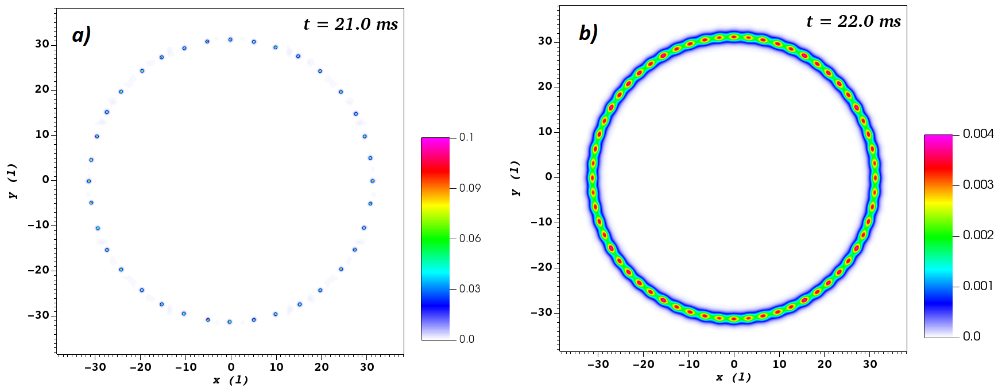

Figure 1. Density distribution in case of a) isolated droplets, b) supersolid state.

