Ultrashort quasi-non-diffracting long-range Gauss-Bessel beams

L. Stoyanov^{1,2}, Y. Zhang¹, A. Dreischuh² and G. G. Paulus^{1,3}
¹Institute of Optics and Quantum Electronics, Friedrich Schiller University,
Max-Wien-Platz 1, D-07743 Jena, Germany
²Department of Quantum Electronics, Faculty of Physics, Sofia University,
5, J. Bourchier Blvd., Sofia-1164, Bulgaria
³Helmholtz Institute Jena, Helmholtzweg 4, D-07743 Jena, Germany
e-mail:l.stoyanov@phys.uni-sofia.bg

Bessel beams (BBs) are one of the four known types of exact solutions of the Helmholtz equation describing non-diffracting beams in circular cylindrical coordinates [1,2]. Non-diffracting means that the central maxima of these beams are remarkably resistant to diffractive spreading [3,4]. Precisely speaking, the BB has an infinite number of rings carrying infinite power/energy, and hence, cannot be generated in the exact sense. However, Durnin and co-authors showed first [5] that one can generate its reasonable approximation by placing an annular slit in the back focal plane of a lens.

Here we demonstrate a straightforward yet efficient method for generating zeroth- and first-order Gauss-Bessel beams (GBBs) using a single reflective spatial light modulator (SLM). These GBBs can be generated in the fields of few-cycle femtosecond laser pulses by initially nesting and subsequently annihilating multiple-charged optical vortices (OVs) and finally Fourier-transforming the resulting ring-shaped beam with a large ring radius-to-width ratio by a thin lens.

Even in the sub-8-fs range there are no noticeable consequences for the measured pulse duration [6]. The only effect is a weak “coloring” of the outer-lying satellite rings of the beams due to the spectrum spanning over more than 300 nm. The obtained beams have diffraction half-angles below 40 μrad and reach propagation distances in excess of 1.5 m. At large propagation distances, the quality of the generated GBBs significantly surpass this of GBBs created by low angle axicons. Detailed results will be presented and discussed.

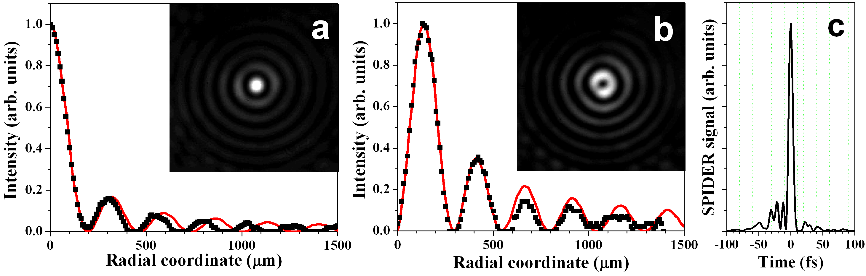
Figure 1. Radial cross-section of the experimentally and theoretically obtained zeroth- (a) and first-order (b) GBBs. Inset frames – experimentally recorded energy density distribution of these GBBs obtained by the creation and subsequent annihilation of an OV with topological charges |TC|=30 (a) and of an OV with TC = 31 and −30 (b). Typical reconstructed GBB pulse profile (pulse duration ∼7.5(±0.5) fs), retrieved from SPIDER device (c) [6].

REFERENCES
[1] J. Durnin, Opt. Soc. Am. A 4, 651–654 (1987).
[2] S. N. Khonina, A. V. Ustinov, S. Chávez-Cerda, J. Opt. Soc. Am. A 35, 1511–1517 (2018).
[3] Z. Bouchal, J. Phys. 53, 537–578 (2003).
[4] D. McGloin, K. Dholakia, Contemp. Phys. 46, 15–28 (2005).
[5] J. Durnin, J. J. Miceli Jr., J. H. Eberly, Phys. Rev. Lett. 58, 1499–1501 (1987).
[6] L. Stoyanov, Y. Zhang, A. Dreischuh, G. G. Paulus, Optics Express 29, 10997–11008 (2021).

