Bio-inspired holey submicrometer plasmonic core-shell particles
as generalized synthetic brochosomes

Z. Jakšić, M. Obradov, O. Jakšić, D.Tanasković
Centre of Microelectronic Technologies
Institute of Chemistry, Technology and Metallurgy - National Institute of the Republic of Serbia
University of Belgrade, Njegoseva 12, 11000 Belgrade, Serbia
e-mail:jaksa@nanosys.ihtm.bg.ac.rs

Brochosomes are aperture-riddled submicrometer hollow spherical particles consisting of proteins and lipids (Fig. 1a) that are produced by some insects (e.g. leafhoppers) and that simultaneously perform a role of superhydrophobic protection against sticking the insect to plants sap and serving as antireflective coatings in the visible to reduce observability by predatory species [1]. Attracting researchers’ attention by their multifunctionality, brochosomes had been artificially produced in various materials, including among others plasmonic materials. From the photonics point of view, so far they have been used as ultra-antireflective diffractive coatings [2] and as photoanodes in photoelectrochemistry [3].

In this work we propose generalized geometries (Fig. 1b,c) of synthetic brochosomes containing free-electron conductors (i.e. plasmonic materials) that can be nanofabricated by first depositing small spheres on the plasmonic shells of core-shell submicrometer particles at various depths and then subtracting them from the shell material, as described in detail in [1]. We performed simulation of the electromagnetic parameters of the novel structures using the finite element method. We succeeded in obtaining ultralow reflection coefficients in an extended wavelength range while simultaneously achieving high geometry-based control over frequency shifting and shape of the spectral characteristics of scattering parameters (Fig.1d). The main advantage of using our plasmonic-based artificial brochosomes is their multifunctional applicability (at the same time they serve as antireflective, superhydrophobic and highly porous structures with parameters controllable by design), which is highly convenient for numerous microoptoelectromechanical (MOEMS) systems.
d) 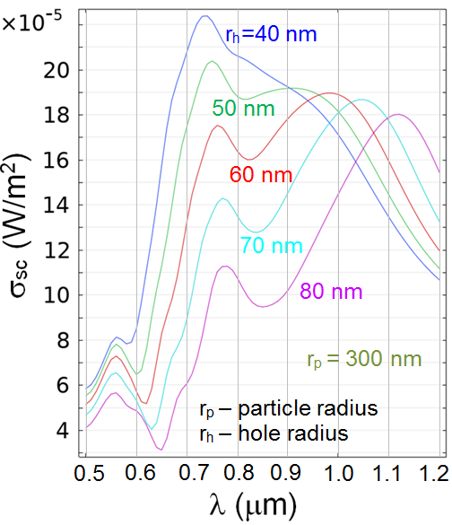
Figure 1. Brochosome geometries. a) top: Electron micrograph of leafhopper brochosomes; bottom: schematics of its cross-section. b-c: our alternative geometries; red: metal. Positions and diameters of spheres subtracted from the starting core-shell plasmonic particle are used as varying parameters. d) FEM-calculated spectral scattering cross-section of the structure shown in b-top, plasmonic shell material is gold.
REFERENCES
[1] S. Yang, N. Sun, B. Stogin, J. Wang, Y. Huang, T. S.. Wong, Nature comm, 8(1), 1-8 (2017).
[2] C. W. Lei, R. Y. Chen, H. Yang, Langmuir, 36(19), 5296-5302 (2020).
[3] Q. Pan, H. Zhang, Y. Yang, C. Cheng, Small, 15(28), 1900924, (2019).

