**Thulium-doped titanate-germanate glasses for infrared photonics**

K. Kowalska1, M. Kuwik1, J. Pisarska1 and W.A. Pisarski1

1*University of Silesia, Institute of Chemistry, Katowice, Poland*

e-mail: karolina.kowalska@us.edu.pl

Thulium-doped inorganic glasses have a great deal of attention due to their near-infrared emissions at about 1450 nm and 1800 nm, respectively. The near-infrared luminescence at 1450 nm corresponds to 3H4→3F4 transition of Tm3+ ions [1] and it is really important for the S-band signal amplification [2]. The second luminescence line at 1800 nm related to the 3F4→3H6 transition of Tm3+ ions is useful for near-infrared fiber laser applications [3]. The systematic studies indicate that the choice of both the glass-host and activator (Tm3+) concentration is very important to obtain excellent spectroscopic properties and to develop more efficient optical devices based on thulium ions. From literature data it is also well evident that titanium dioxide TiO2 has a positive effect on the 1800 nm fluorescence performance of tellurite glass, while the introduction of GeO2 has great advantages in enhancing the glass thermal stability [4].

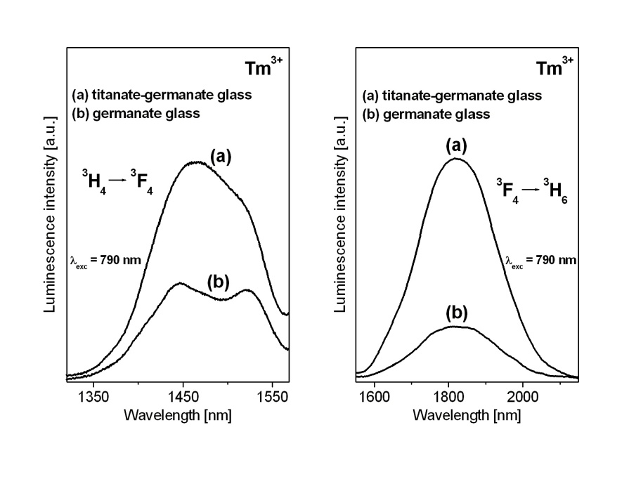

Figure 1. Near-infrared luminescence spectra of Tm3+ ions in titanate-germanate glass.

Here, we present our preliminary investigations for TiO2-modified germanate glass doped with Tm3+. Figure 1 shows two main emission bands at 1450 nm and 1800 nm corresponding to the 3H4→3F4 and 3F4→3H6 transitions of Tm3+ ions in germanate glass modified by TiO2. In both cases, luminescence bands are enhanced significantly in the presence of TiO2. It confirms our previous results obtained for europium ions in titanate-germanate glass, where orange-reddish emission was increased drastically in comparison to glass sample without TiO2 [5]. Our preliminary results suggest that titanate-germanate glass doped with thulium ions is promising candidate for potential near-infrared laser applications.

Acknowledgment: This research was funded by National Science Centre (Poland), grant number 2018/31/B/ST8/00166.

REFERENCES

[1] R. Balda, LM. Lacha, J. Fernandez, MA. Arriandiaga, JM. Fernandez-Navarro, D. Munoz-Martin, Opt. Exp. 16, 11836 (2008).

[2] D.L. Yang, E.Y.B. Pun, H. Lin, Appl. Phys. Lett. 95, 151106 (2009).

[3] X. Wen, G. Tang, J. Wang, X. Chen, Q. Qian, Z. Yang, Opt. Exp. 23, 7722 (2015).

[4] W. Tang, Y. Tian, B. Li, Y. Xu, Q. Liu, J. Zhang, S. Xu, Ceram. Int. 45, 16411 (2019).

[5] W.A. Pisarski, K. Kowalska, M. Kuwik, J. Polak, E. Pietrasik, T. Goryczka, J. Pisarska, Materials 13, 4422 (2020).