Influence of light guide type on dental composite polymerization shrinkage
– a holographic and thermographic study

E. Novta¹, T. Lainović¹, S. Savić-Sević², D. Grujić², D. Pantelić² and L. Blažić^{1,3}
¹University of Novi Sad, Faculty of Medicine, School of Dental medicine, Novi Sad, Serbia
²University of Belgrade, Institute of Physics, Belgrade, Serbia
³Dental Clinic of Vojvodina, Novi Sad, Serbia
e-mail: evgenije.novta@mf.uns.ac.rs

Polymerization shrinkage stress (PSS) is generated at the tooth-restoration interface, during setting of a dental resin-based composite (RBC) inside a tooth cavity. As a result, various negative clinical outcomes may arise. In addition, the polymerization reaction is followed by heat release due to its exothermic nature. The aim of this study was to investigate the influence of two different light guides on PSS, by detecting tooth model deformation using digital holographic interferometry (DHI). Simultaneously, temperature rise measurements were conducted using infrared thermography (IRT).

Standardized tooth models made of dental gypsum, with a mesial-occlusal-distal (MOD) cavity, were used for the purposes of this study. The specimens were mounted in aluminum blocks and fixed in the custom-made holographic set-up with a Nd:YVO₄ laser at 532nm wavelength and power of 400mW. The cavities were filled with a bulk-fill RBC. Two groups of specimens (n=10) were used. In the first group (G1), a light guide (ϕ 8mm) of a commercial LED light source was used in continuous 40s curing mode. In the second group (G2), three optical fibers (ϕ 1mm), connected to the same light source, were inserted into the dental filling to cure the RBC from within [1] (the first phase–3x40s). After removal of the optical fibers from the RBC, the remaining voids were filled and the specimens were additionally cured (the second phase–40s). Tooth model deformation due to PSS was detected in real-time using DHI, while simultaneously monitoring temperature rise of the RBC using IRT. Statistical analysis was performed using student’s t-test for independent samples.

In group G2, the DHI images during the first phase of light curing using optical fibers, demonstrated initiation of the polymerization reaction and tooth model deformation. The final deformation value (after the first and second phase) in group G2 (M=14.3µm) was significantly lower (on average 5.2µm, p˂0.05) compared to final deformation value in group G1 (M=9.1µm) (Figure 1.). The resulting IRT images, presented a gradual temperature increase in group G2, postponing the estimated gel-point of the polymerization reaction, which could be related to PSS relaxation (Figure 2.).

Within the limitations of this study, it was concluded that polymerization reaction initiation using optical fibers influenced lower polymerization shrinkage and gradual temperature increase during polymerization. Accordingly, optical fibers could contribute to overcoming the dental PSS problem.
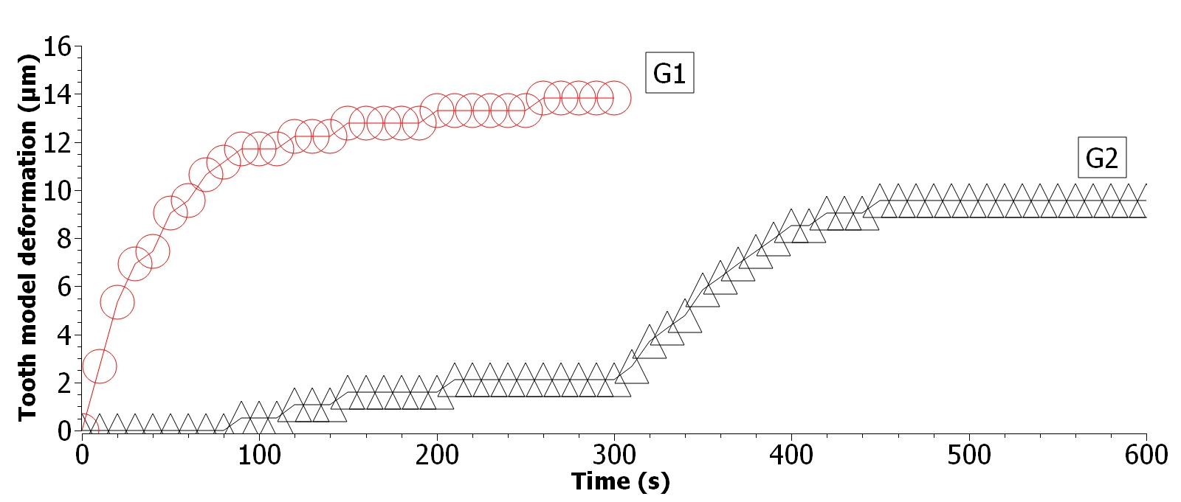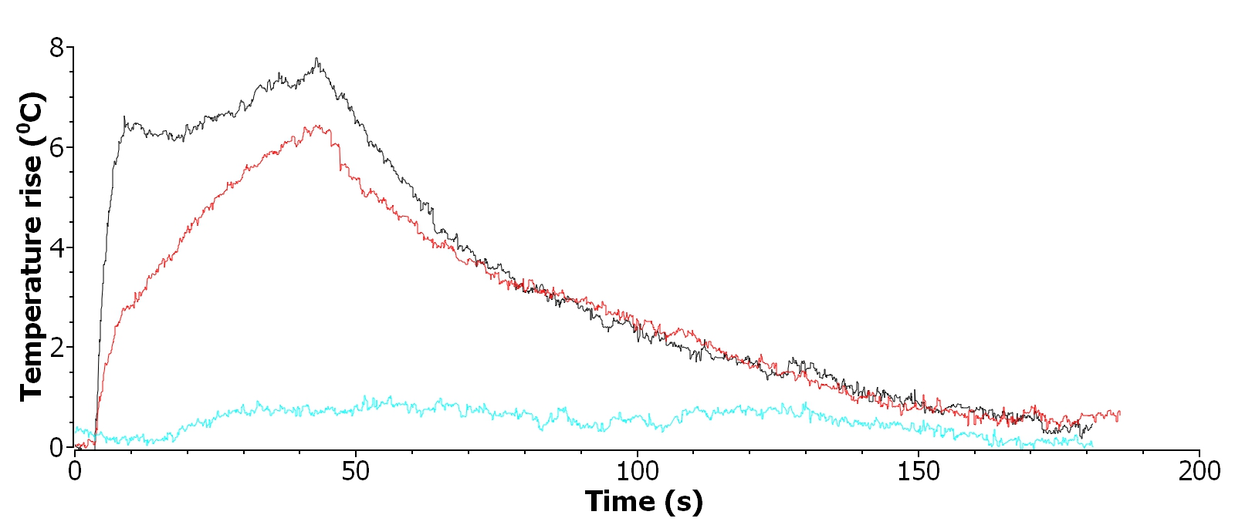
Figure 1. Ellipse-G1 group, standard curing mode; triangle-G2 group, two-phase curing with optical fibers and standard light guide
Figure 2. Black-G1 group, standard curing mode; green-G2 group, first phase curing with optical fibers; red-G2 group, second phase-standard curing mode

REFERENCES [1] F.A. Rueggeberg. Dent. Mater. 2011;27(1):39–52.
Supported by the contract NIO200114 and Mikodental, Šabac (distributers of Shofu®, Japan in Serbia)

