Effects of laser heating on luminescent properties of Gd₂O₃:Er,Yb nanophosphor

D. Sevic¹, M.S. Rabasovic¹, J. Krizan², S. Savic-Sevic¹, M.D. Rabasovic¹, B.P. Marinkovic¹
and M.G. Nikolic¹
¹Institute of Physics, Belgrade, Serbia
²AMI d.o.o., Ptuj, Slovenia
e-mail:sevic@ipb.ac.rs

In this study we analyze effects of laser heating on luminescent properties of nanocrystalline Gd₂O₃ doped with Er³⁺ and Yb³⁺ cations. Material was synthesized by combustion method, as described in [1]. Our experimental setup is presented in detail in [2,3,4]. In this study we have used pulsed laser diode excitation at 980 nm. Variable laser pulse energy was obtained by varying the laser pulse duration. Used laser diode has both continual and pulse mode. In continual mode its power is 1 W; in pulse mode it is possible to tune pulse duration and repetition, thus obtaining different average excitation powers. Here, we have used repetition rate of 200 Hz, with varying pulse duration between 20 µs and 200 µs, so average excitation power is between 8 mW and 80 mW.

Generally, laser power heating effects are unwanted and should be avoided in luminescence thermometry experiments; external heater and thermometer are used to calibrate the temperature sensing curve. Interestingly enough, the thermometry system, based on laser heating of sample, applicable for biomedical purposes, is described in [5].

Luminescence spectra of Gd₂O₃:Er³⁺,Yb³⁺ excited at room temperature with different laser excitation powers are shown in Figure 1. It should be noted that excitation power is intentionally much higher than used in [3]. Based on temperature sensing calibration curve presented in [3] for the same sample it could be estimated that the material is locally heated to about 375 K for pulse time of 200 µs.
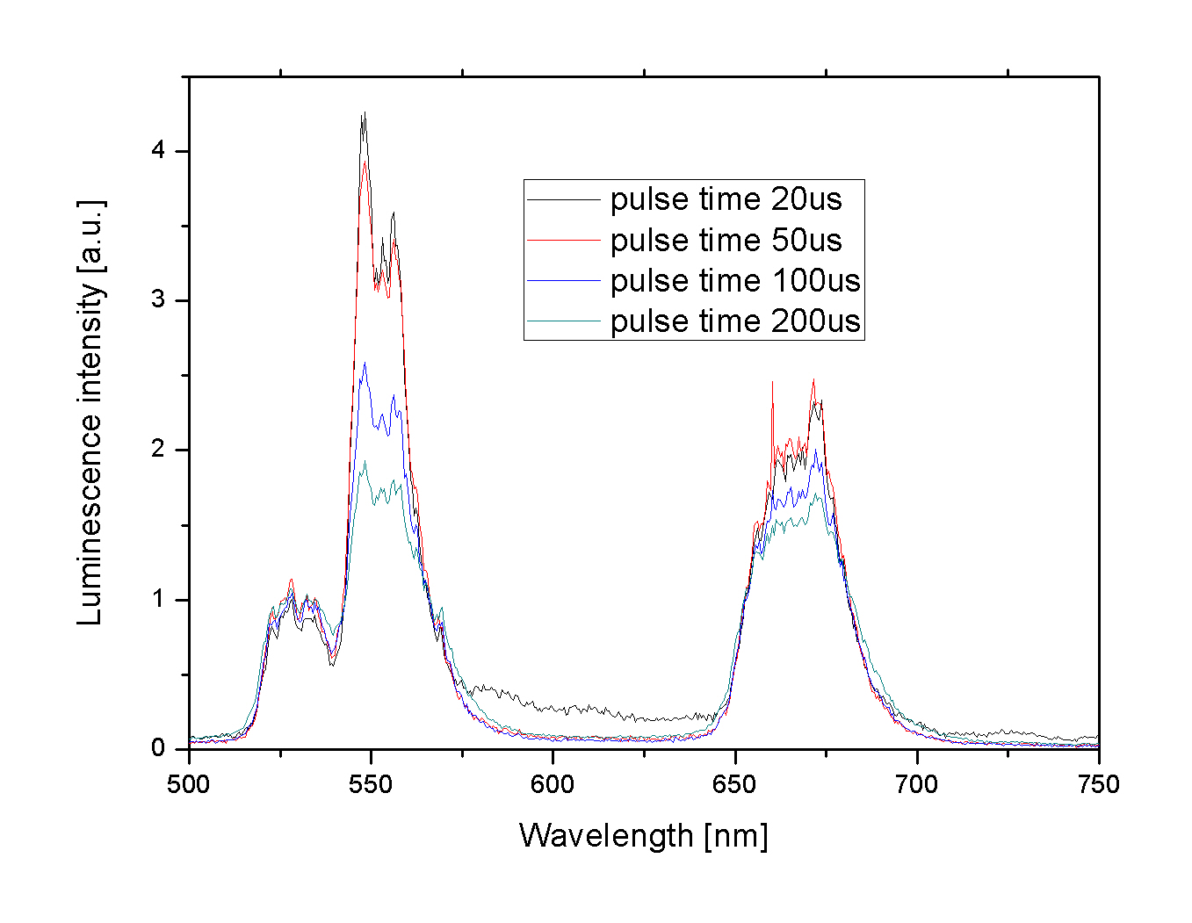
Figure 1. Luminescence spectra of Gd₂O₃:Er³⁺,Yb³⁺ excited at room temperature with different laser powers.
REFERENCES
[1] J. Krizan, M. Mazaj, V. Kaucic, I. Bajsic, J. Mozina, Acta Chim. Slov. 61, 608 (2014).
[2] A. Vlasic, D. Sevic, M.S. Rabasovic, J. Krizan, S. Savic-Sevic, M.D. Rabasovic, M. Mitric,
B.P. Marinkovic, M.G. Nikolic, Journal of Luminescence, 199, 285 (2018).
[3] D. Sevic, M.S. Rabasovic, J. Krizan, S. Savic-Sevic, M.D. Rabasovic, B.P. Marinkovic,
M.G. Nikolic, Optical and Quantum Electronics 52, 232 (2020).
[4] D. Sevic, M.S. Rabasovic, J. Krizan, S. Savic-Sevic, M.G. Nikolic, B.P. Marinkovic, M.D. Rabasovic, J. Phys. D: Appl. Phys. 53, 015106 (2020).
[5] M.F. Ferreira, K.Z.R. de Sousa, W.L. Massarotto, E.G. Ricci, E.H. de Faria, K.J. Ciuffi,
D. Sevic, L.A. Rocha, E.J. Nassar, J. Braz. Chem. Soc., 32(2) 376 (2021).

