**Interaction of ultrashort laser pulses with hemoglobin as a tool for selective erythrocytes photo-labeling**

M. Radmilovic1, I. Drvenica2 , M. Rabasovic1, V. Ilic2, D. Pavlovic1, S.Nikolic1, M. Matic3 and A. Krmpot1

1*Institute of Physics Belgrade, Serbia*

2*Institute for Medical Research, University of Belgrade, Serbia*

3*Institute of Oncology and Radiology of Serbia*

e-mail:mihajlo.radmilovic@ipb.ac.rs

Interaction of hemoglobin (Hb) with ultrashort laser pulses is followed by fluorescence detection [1, 2]. The photophysical nature of fluorescence from Hb-containing specimens is not completely understood so far. There is some evidence of photoproduct formation in the process of Hb interaction with ultrashort laser pulses [3].

We measured Uv-Vis and Two-photon emission spectra of formed photoproduct in the way that Hb thin film was previously treated with a femtosecond Ti: Sapphire laser operating on 730nm. A relative relation and position of Uv-Vis Hb characteristic peaks such as Soret peak (410 nm) , α and β peaks (577 nm and 541 nm respectively) served as a marker of structural changes in the laser treated Hb films[4].

Results suggest that the interaction of Hb with ultrashort laser pulses probably leads to the photodegradation of Hb, due to changes in α, β peaks relative relation and red shift of Soret peak in photoproduct Fig. 1 a).

Moreover, we emphasize that the photoproduct formed on thin Hb films has long durability, since we were able to detect its fluorescence after several months. This opens a possibility to apply the formed photoproduct as optical data storage and security tag.

We have also induced photoproduct formation in the human healthy erythrocytes Fig. 1 b) in order to selectively “label” and make them fluorescent in a whole blood. Two-photon selective labeling of erythrocytes can be used as a tool for studying red blood cells with different fluorescence detection methods, due to photoproduct fluorescence. This can be potentially applied in studying hemoglobin and erythrocytes in various physiological and pathophysiological states.

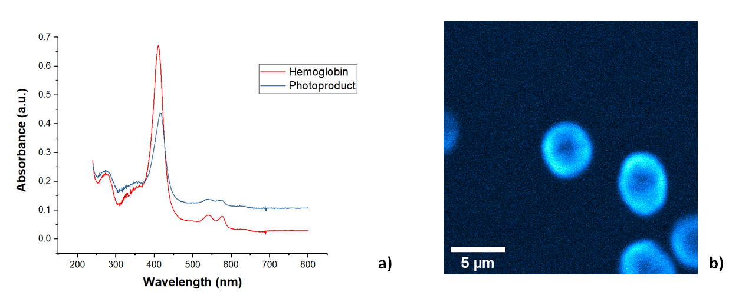

Figure 1. a) Uv-Vis absorption spectra of hemoglobin (red) and formed photoproduct (blue), b) Two-photon fluorescence image of selectively chosen erythrocytes with induced photoproduct formation.

Funding: Project HEMMAGINERO, No 6066079

REFERENCES

[1] D. Li, W. Zheng, Y. Zeng, Optics Lett. 36, 834 (2011).

[2] K. Bukara, S. Jovanic, I. Drvenica, J. Biomed. Opt. 22.2, 026003 (2017).

[3] E.A.Shirshin, B.P.Yakimov, S.A.Rodionov, Laser Phys. Lett. 15, 075604 (2018).

[4] E.H.Hanson, J.Ballantyne, PLoS One 5, e12830 (2010).