Structural and Optical Characterization of titanium-carbide and polymethyl methacrylate based nanocomposite

J. Pešić¹, A. Šolajić¹, J. Mitrić¹, M. Gilić¹, I. Pešić², N. Paunović¹, N. Romčević¹
¹1Institute of Physics Belgrade, University of Belgrade,
Pregrevica 118, 11080 Belgrade, Serbia;
²Faculty of Technology and Metallurgy, University of Belgrade,
11000 Belgrade, Serbia
e-mail: yelena@ipb.ac.rs

The rich chemistries and unique morphologies of titanium carbide MXenes made them strong candidates for many applications like sensors and electronic device materials [1]. They can potentially be used as additives to polymers to fabricate composites with outstanding mechanical properties and good electrical conductivities. Presence of titanium-dioxide as a residue of MXene chemical synthesis is researched for it potential benefit on electrochemical properties [2].

In this study we present structural and optical characterization of such polymer nanocomposite titaniumcarbide/PMMA (Polymethyl methacrylate) consisting of Ti₃C₂, TiC₂ MXenes and TiC, and TiO₂ residues of synthesis in PMMA matrix, as a multicomponent nanocomposite.
Using XRD, SEM, infrared and Raman spectroscopy, followed by comparative study on the vibrational properties using density functional theory calculations we characterize this nanocomposite.

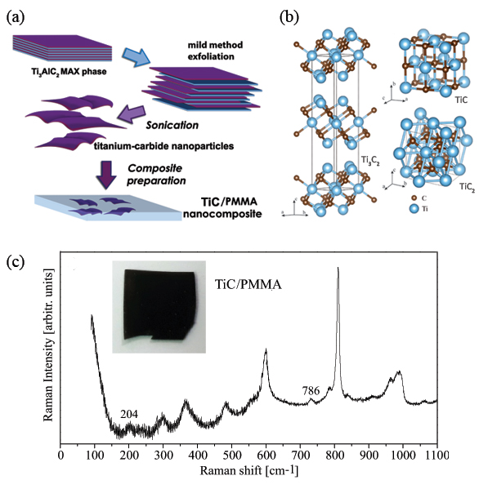

Figure 1. a) Schematic describing the synthesis process and preparation of composite starting from the Ti₃AlC₂ MAX phase b) Schematic representation of titanum-carbide structures present at the composite c) Raman spectrum of TiC/PMMA nanocomposite with titanium-carbide related peaks marked. Inset: photo of the sample.
REFERENCES
[1] Naguib, M.; Kurtoglu, M.; Presser, V.; Lu, J.; Niu, J.; Heon, M.; Hultman, L.; Gogotsi, Y.; Barsoum, M.W., Advanced Materials 2011, 23, 4248–4253.
[2] Zhu, J.; Tang, Y.; Yang, C.; Wang, F.; Cao, M., Journal of The Electrochemical Society 2016, 163, A785–A791.

