**Modeling of intersubband transitions in ZnO/ZnMgO Coupled   
Quantum Wells**

A. Atić1,2, J. Radovanović2, N. Vuković2

1*Vinča Institute of Nuclear Sciences, Belgrade Serbia*

2*School of Electrical Engineering,*

*University of Belgrade, Serbia*

e-mail: atic@vin.bg.ac.rs

In recent years ZnO has become a popular semiconductor with many potential applications in infra-red and THz optical devices owing to a wide direct bandgap (3.4 eV) in combination with relatively high exciton binding energy (60 meV) [1]-[2]. In this work, we model the electronic structure of coupled oxide-semiconductor quantum wells by numerically solving the system of coupled Schrödinger-Poisson equations self-consistently (Fig. 1). We compare the obtained results with the recent experimental data [3] and analyze how the variation of the layers’ thicknesses affects the energy states. In addition, we examine the influence of doping to assess the differences between single well and two wells’ cases, for the purpose of designing more complex multi-well optical system in the future.

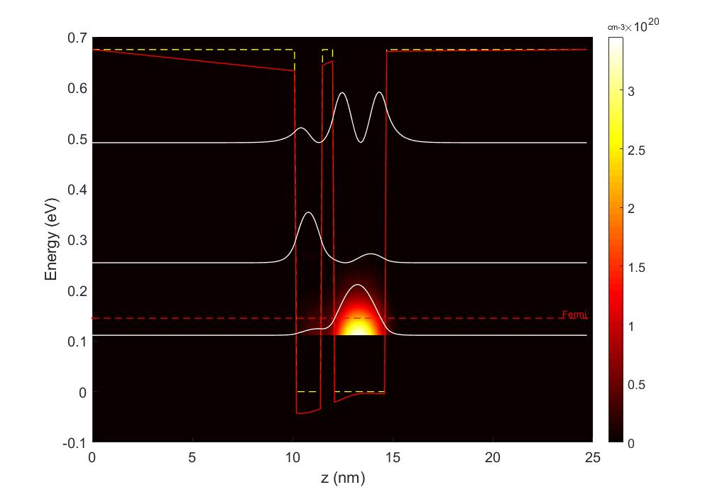

Fig 1. Calculated conduction band of a double well ZnO/ZnMgO structure, together with wavefunctions squared, for a structure with 0.5 nm thick barrier at room temperature (300 K) with uniform layer doping $n ≅10 × {10}^{18}{cm}^{-3}$ [3].

REFERENCES

[1] M. Belmoubarik, K. Ohtani, and H. Ohno, “Intersubband transitions in ZnO multiple quantum wells,” *Appl. Phys. Lett.*, 2008.

[2] N. Le Biavan *et al.*, “Homoepitaxy of non-polar ZnO/(Zn,Mg)O multi-quantum wells: From a precise growth control to the observation of intersubband transitions,” *Appl. Phys. Lett.*, 2017.

[3] B. Meng *et al.*, “Observation of Intersubband Absorption in Zn O Coupled Quantum Wells,” *Phys. Rev. Appl.*, 2019.