Tracking of the temporal dependency of fading of the human footprint temperature contrast

S. Djenadic¹, Lj. Tomic², V. Damnjanovic¹, D. Vasiljevic³, D. Pavlovic³
¹University of Belgrade, Faculty of Mining and Geology, Djusina 7, Belgrade, Serbia
²Military Technical Institute, Ratka Resanovica 1, Belgrade, Serbia
³ University of Belgrade, Institute of Physics, Photonics Center, Pregravica 118, Belgrade, Serbia
e-mail: stevan.djenadic@rgf.bg.ac.rs

In certain situations, it is extremely important to determine the exact time “someone” entered or crossed the forbidden zone of a military or strategic installation, a red zone of radioactive, chemical or biological contamination, a bank or similar structure. Standard security measures include ordinary video surveillance using cameras that operate in the visible range of the electromagnetic spectrum, as well commercial thermal imaging cameras [1, 2]. The paper presents the results of experiments that suggest another possible use of infrared (IR) thermography – tracking of the time dependency of fading of the human footprint temperature contrast.

The results are based on analyses of thermal images captured by a FLIR SC620 camera with an uncooled microbolometer detector VOx of 640 × 480 pixels. The standard field of view of the camera is 24° × 18°, the spatial resolution 0.65 mrad and the NETD sensitivity less than 40 mK. The thermal imaging frequency was set at 30 Hz. Two of the thermal images of the surface of a carpet, after it was stepped over or after heat was transferred to the cold surface of the flooring, are shown in Figure 1. Several IR sequences and a series of thermal images were selected to analyze the temperature contrast in the zone of interest over time. The temperature contrast history, or the difference between the surface temperature of the footprint and the floor, shows “when the intruder invaded the forbidden zone”.

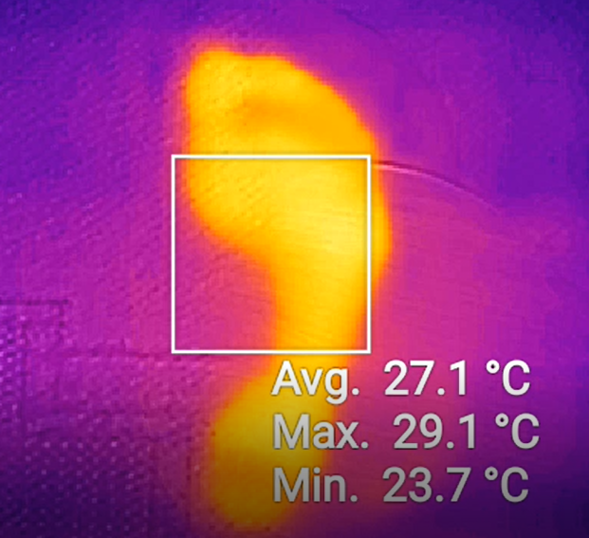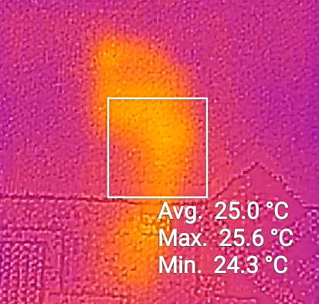
Figure 1. Thermal image of footprint on carpet:
Left 1 s after beginning of imaging;
Right – 30 s after beginning of imaging.

REFERENCES

[1] S. W. Harmer, C. I. Johnson, D. Wheeler, and H. Bhabha. PIER M. 88, 83-89 (2020).
[2] L. Tomić, V. Damnjanović, G. Dikić, and B. Milanović. Appl. Sci. 9, 1854 (2019).

