**Slow light under double-double EIT regime in spherical quantum dot with hydrogen impurity**

N. Filipović and V. Pavlović

*Department of Physics, Faculty of Sciences and Mathematics, University of Niš, Serbia*

e-mail: nikola.filipovic@pmf.edu.rs

Throughout the decades, a lot of attention has been devoted to the study of the light manipulation, with various applications in quantum optics and photonics [1]. One prosperous application is slow light, obtained by reducing the group velocity of light by several orders of magnitude [2,3]. The technique largely used to achieve such an effect is via the electromagnetically induced transparency (EIT). This phenomenon allows the medium, previously opaque for the weak probe laser, to become transparent in the presence of another, strong control field [4].

Typically, the EIT is obtained with two lasers. However, adding another control field can lead to the formation of two transparency windows, which is called double-double EIT [5]. In this paper, this type of coupling is achieved by using the four-level cascade scheme, with the levels 1*s*0, 2*p*–1, 3*d*–2 and 4*f*–3 of the GaAs spherical quantum dot (SQD) with the on-center hydrogen impurity. The probe field *Ep* couples the levels 1*s*0 and 2*p*–1, while control fields *Ec*1 and *Ec*2 excite transitions 2*p*–1 ↔ 3*d*–2 and 3*d*–2 ↔ 4*f*–3, respectively. Using semiconductor quantum dots, where the charge carriers are confined in all three dimensions, improves the implementation and controllability of the experimental setup [6].

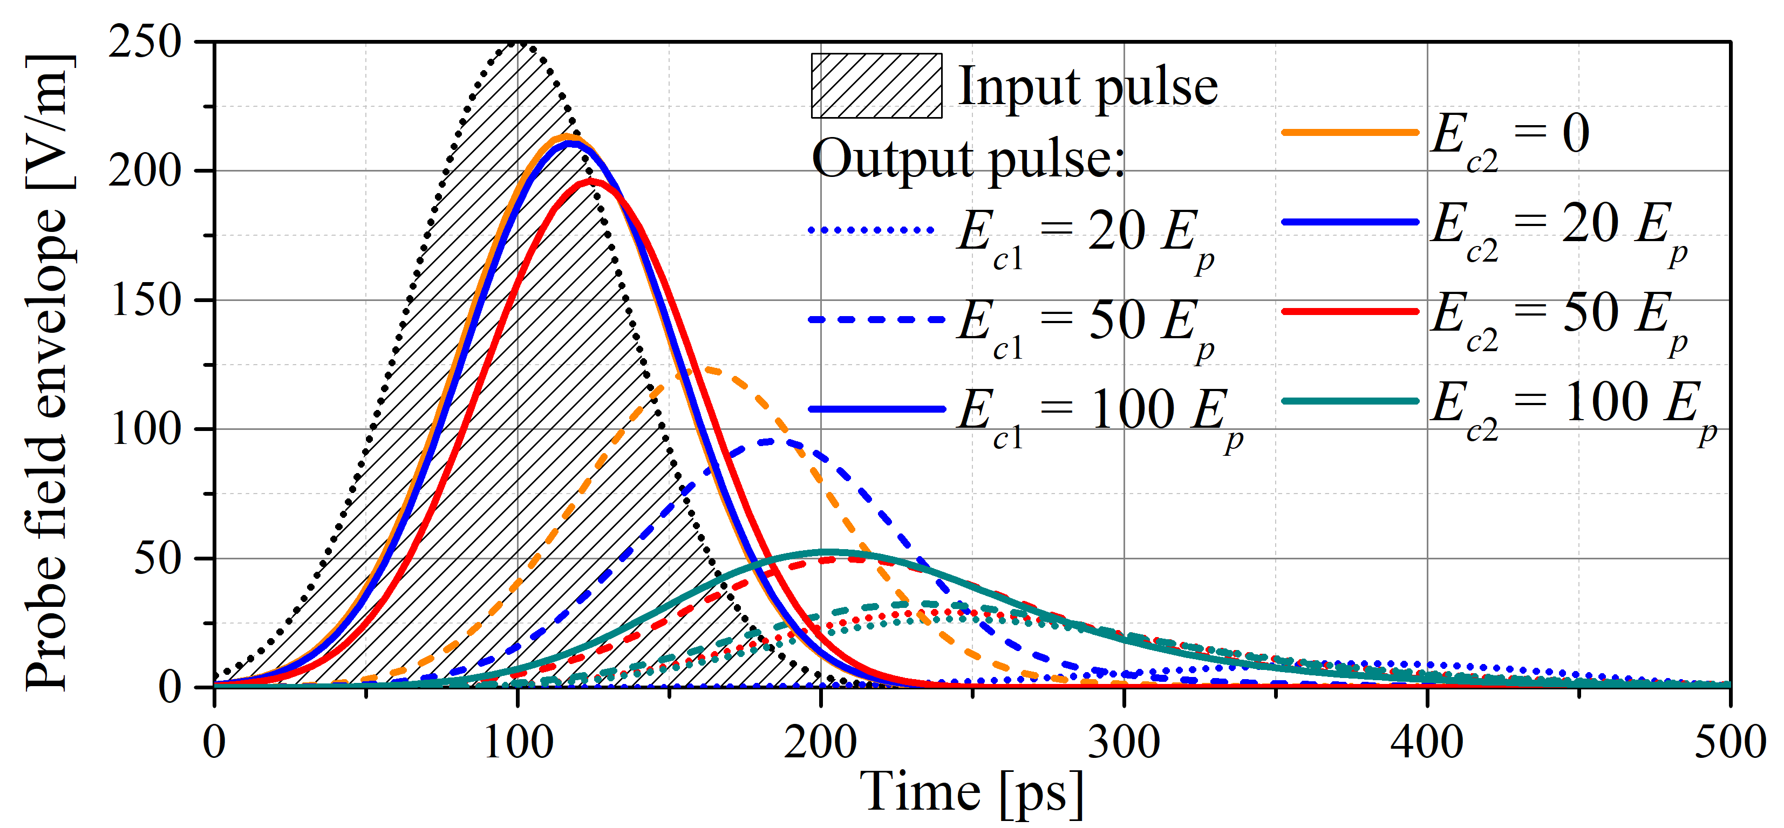

Figure 1. The temporal profile of the input and output probe pulse envelope for several values of the electric field of the two control lasers.

To investigate the weak probe pulse propagation through the SQD under the presence of two strong cw control fields, Maxwell-Bloch equations are solved by using the Fourier transform method. The central result is shown in Fig. 1. The group velocity of the output pulse can be reduced by decreasing *Ec*1, which also reduces the efficiency. On the other hand, the switch-on and further increase of *Ec*2 leads to the formation and increase of the middle absorption peak height, respectively. The position of this peak can be altered by applying the external static magnetic field, which can increase the output pulse efficiency. All the conclusions can be further utilized to contribute to the fields of magnetometry, quantum telecommunications and quantum information processing.

REFERENCES

[1] M. O. Scully, M. S. Zubairy, Quantum Optics, Cambridge University Press, 1997.

[2] L. V. Hau, S. E. Harris, Z. Dutton, C. H. Behroozi, Nature 397, 594 (1999).

[3] D. Budker, D. F. Kimball, S. M. Rochester, V. V. Yashchuk, Phys. Rev. Lett. 83, 1767 (1999).

[4] S. E. Harris, Phys. Today 50, 36 (1997).

[5] H. M. M. Alotaibi, B. C. Sanders, Phys. Rev. A 89, 021802 (2014).

[6] P. C. Ku, C. J. Chang-Hasnain, S. L. Chuang, J. Phys. D Appl. Phys. 40, R93 (2007).