**Search for topological defects of bosonic ultralight field with optically pumped magnetometer: design, calibration, and sensitivity of**

**the Belgrade GNOME station**

S. Topić1,2, and Z. D Grujić1

1*Institue of Physics, Belgrade, Serbia*

2*Faculty of Physics, University of Belgrade, Serbia*

e-mail:sasa.topic.sale@gmail.com

We present the design and calibration of optically pumped magnetometer (OPM), based on a paraffin coated cesium cell, and estimate its ultimate reach in terms of mass and interaction strength of a hypothetical axionic or axion-like dark matter fields in form of a topological defects. Hypothetical axions or Axion Like Particles (ALP‘s) are form of ultralight bosonic matter that are postulated in order to solve strong CP problem, matter-antimatter imbalance in the Universe and may even solve current Lambda Cold Dark Matter (ΛCDM) observational discrepancies and H0 tensions. Dark matter problem, exuberated by negative results of search for WIMP‘s, core-cusp problem, missing satellites problem and others may be solved by a type of ultralight matter model which can reconcile GR and MOND paradigms.

This model has several detectable signatures, one being in the form of axionic field couplings to Standard Model fermions via the pseudomagnetic fields that are generated during passage through topological defects. The GNOME experiment is designed as a GPS referenced worldwide distributed network of quantum cross-correlated sensors that increases its sensitivity, discovery reach and excludes false positives by methodology similar to LIGO network. Belgrade GNOME station is built around a double resonant optical cesium magnetometer in Mx configuration and is functioning as a scalar magnetometer with a sensitivity less than 100 fT/ $\sqrt{Hz}$. We will present different modes of operations, give an overview of atomic magnetometry and quantify various noise contributions. Special attention will be given to PSD, sensitivities, and stability over short and long baselines of the setup. Guidelines for future work and a foreseen improvements shall also be mentioned.

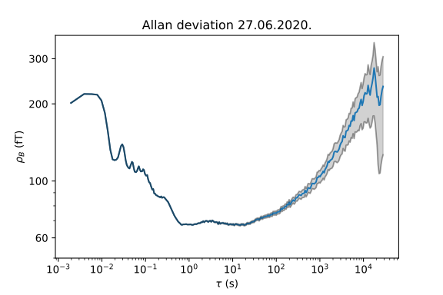

Figure 1. Allan standard deviation of magnetic field recorded by OPM in phase-locked loop.

REFERENCES

[1] D. Budker and M.V. Romalis, Nat. Phys., 23 (2007), 229

[2] M. Pospelov, et al., Phys. Rev. Lett., 110 (2013), 021803

[3] J. Preskill, M. B. Wise and F. Wilczek, Phys. Lett., B120 (1983), 127

[4] S. M. Carroll, Phys. Rev. Lett., 81 (1998), 3067

[5] Pustelny et al., Ann. Phys., 525 (2013), 659-670

[6] M.P. Ledbetter, M.V. Romalis and D.F. Jackson Kimball, Phys. Rev. Lett., 110 (2013), 040402