XUV-driven plasma switch for THz: new spatio-temporal overlap tool for XUV–THz pump–probe experiments at FELs
E. Zapolnova^{1,4}, R. Pan1, T. Golz¹, M. Sindik¹, M. Nikolic¹, M. Temme¹, M. Rabasovic², D. Grujic², Z. Chen³, S. Toleikis¹ and N. Stojanovic¹
¹
¹Deutsches Elektronen-Synchrotron (DESY), Notkestrasse 85, 22607 Hamburg, Germany,
²Institute of Physics Belgrade, Pregrevica 118, 11080 Belgrade, Serbia, and
³SLAC National Accelerator Laboratory, Menlo Park, CA 94025, USA
⁴Class 5 Photonics GmbH, Notkestrasse 85, 22607 Hamburg, Germany
e-mail: ekaterina.zapolnova@@class5photonics.com

Intense THz pulses combined with synchronized X-ray pulses enable investigation of the dynamics of the light–matter interaction, non-linear response of materials and control of the properties of matter selectively on femtosecond time scales. Therefore, achieving the temporal overlap between pump and probe pulses in the femtosecond range is essential for both at table top high harmonic sources and Free Electron Lasers (FELs) [1].

A simple and robust tool for spatio-temporal overlap of THz and XUV pulses in in-vacuum pump–probe experiments is presented. The technique exploits ultrafast changes of the optical properties in semiconductors (i.e. silicon) driven by ultrashort XUV pulses that are probed by THz pulses. It enables the measurements of the arrival time between XUV and THz pulses with temporal resolution on the scale of the duration of the THz pulse. It enables the single shot measurement of the optical constants of the excited materials with the variable XUV wavelength [2].

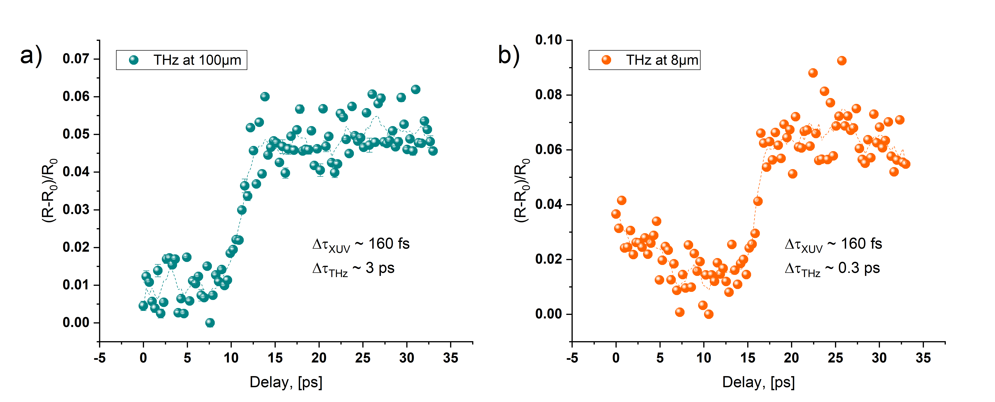
Figure 1. Transient THz reflectivity change of Si, excited by 13.5 nm XUV pulse probed with THz wavelengths of 100 µm and 8 µm.

REFERENCES
[1] E. Zapolnova, R. Pan, T. Golz, M. Sindik, M. Nikolic, M. Temme, M. Rabasovic, D. Grujic, Z. Chen, S. Toleikis and N. Stojanovic, Journal of Synchrotron Radiation, Vol. 27, p.1 (11-16) 2020

[2] Z. Chen, et. al., Nature Communications, 12 (1638), 2021

