Single-shot THz characterization for a new THz/XUV endstation in FLASH2020+

S. Gang¹, R. Pan¹
¹ Deutsches Elektronen-Synchrotron (DESY), Notkestraße 85, D-22607 Hamburg, Germany
e-mail:seung-gi.gang@desy.de

The FLASH1 THz beamline at DESY provides intense THz pulses simultaneously to the FLASH1 soft X-ray beam with only a few femtosecond timing jitter for THz/XUV pump-probe experiments. As a part of the FLASH upgrading project, FLASH 2020+ [1], the FLASH1 will provide flexible polarization and enhanced XUV photon energy beyond carbon K-edge and separation of THz undulator will enable complete independent operation of XUV and THz. A new semi-permanent endstation for THz-XUV pump-probe experiments will be implemented and aim at various scientific researches such as solid state- and surface physics, surface chemistry, and especially femtomagnetism by various experimental geometries such as reflection- (for transverse magneto-optic Kerr effect, T-MOKE) or transmission (for magnetic small-angle X-ray scattering, SAXS) geometry. Online photon diagnostics for the THz pulses are under development and will provide the THz temporal- and spectral profile on a single-shot basis. For this purpose, single-shot diagnostics employing electro-optic sampling has been experimentally carried out [2,3]. A reflective echelon mirror with size of 30 mm by 30 mm was employed to introduce a series of probe pulses with 50 fs of timing interval as a temporal resolution. The probe pulses cover the temporal range of 10 ps which is employed for single-shot diagnostics of THz. Measured temporal profile and spectrum of THz pulse from single-shot method proves the practical availability of the single-shot diagnostics of THz pulse at FLASH1 after the FLASH 2020+ project.

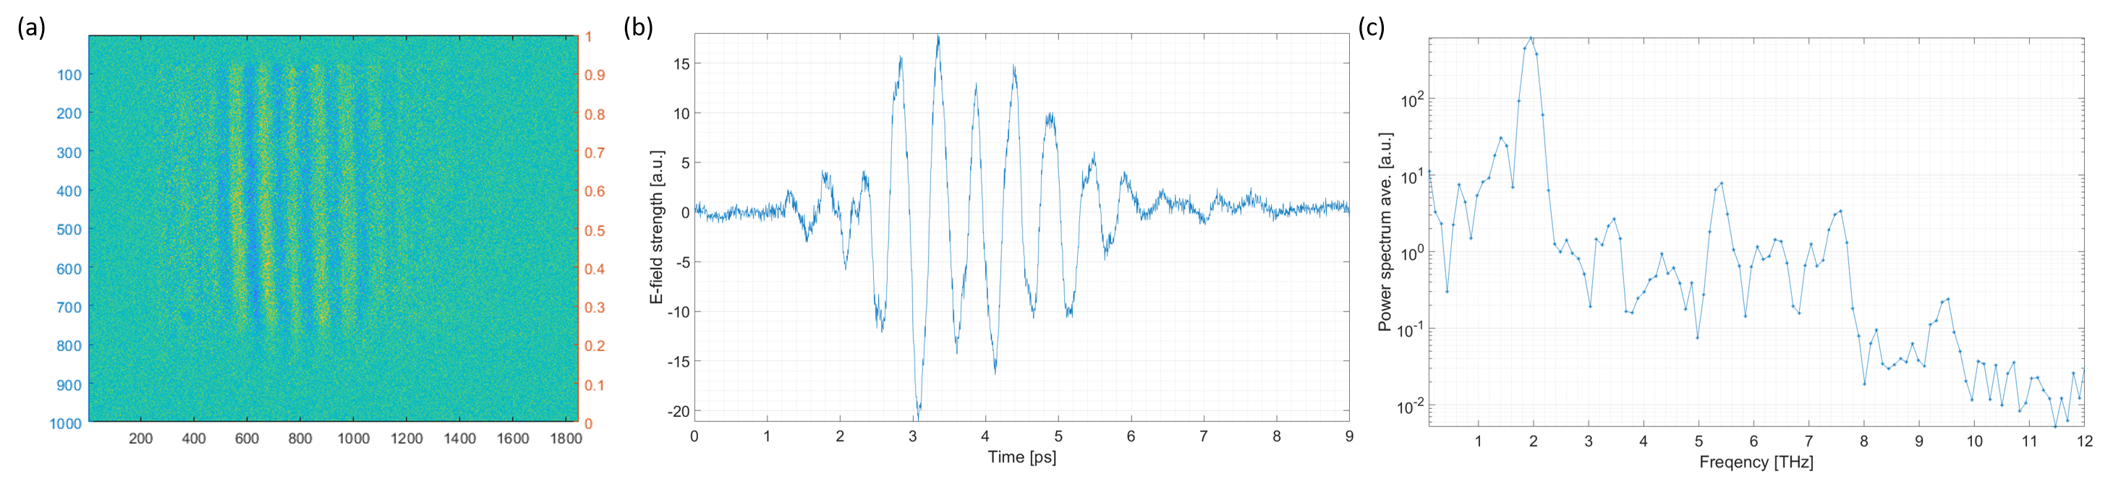
Figure 1. Results of single-shot THz diagnostics (a) Image of probe laser pulse after intensity modulation by THz field (b) Electric field of THz pulse (c) Measured THz (155 um) spectrum in frequency.

REFERENCES
[1] 'FLASH2020+ Conceptual Design Report' (CDR), (2020).
[2] K. Y. Kim, B. Yellampalle, and et al., 'Single-shot terahertz pulse characterization via two-dimensional electro-optic imaging with dual echelons', Opt. Lett. 32, 1968-1970 (2007)
[3] G. Timothy Noe, I. Katayama, and et al., 'Single-shot terahertz time-domain spectroscopy in pulsed high magnetic fields', Opt. Express 24, 30328-30337 (2016)

