Hyperbolic Metamaterials via Hierarchical Block Copolymer Nanostructures
Marwan Channab^{1,2}, Irdi Murataj^{1,2}, Eleonora Cara², Candido F. Pirri¹, Luca Boarino², Angelo Angelini², Federico Ferrarese Lupi²
¹Dipartimento di Scienza Applicata e Tecnologia, Politecnico di Torino, Turin, Italy
²Advanced Materials and Life Sciences, Istituto Nazionale di Ricerca Metrologica (INRiM), Turin, Italy
e-mail: marwan.channab@polito.it

Extremely exotic optical properties unattainable in natural materials can be shown by an innovative class of materials: hyperbolic metamaterials (HMMs). Exploiting HMMs, it is possible to obtain the confinement of light at the nanoscale and the enhancement of spontaneous emission of a coupled emitter. Most of the HHMs are fabricated by sequential deposition of alternating metal/dielectric layers to obtain a multilayer structure. In this case, the optical axis lies in the out-of-plane direction. This particular feature causes many issues for their exploitation into more complex integrated photonic devices such as a difficult radiation outcoupling. Since in-plane orientation of the optical axis is desirable for different applications in nanophotonics and imaging, we present a method for fabricating localized HMMs with in-plane optical axis based on the dewetting of block copolymer (BCP)/homopolymer blend thin films [1]. We obtained droplets composed of highly ordered lamellar nanostructures in hierarchical configuration by exploiting the blend film instability over topographically defined substrates, see figures 1.a−1.c. The pattern transfer process onto a flexible substrate creates an Au/air HMM with hyperbolic dispersion in broad wavelength range in the visible spectrum. Moreover, we obtained a strong reduction in the measured fluorescence lifetime of NV centers in nanodiamonds placed on top of the HMM. This measurement is supported by computed Purcell factor as high as 32 at 580 nm, see figures 1.d and 1.e. To conclude, we proposed a method to obtain hybrid metal/dielectric nanopatterned substrates in a fast and low-cost way with in-plane optical axis whose spectral response can be further tuned.

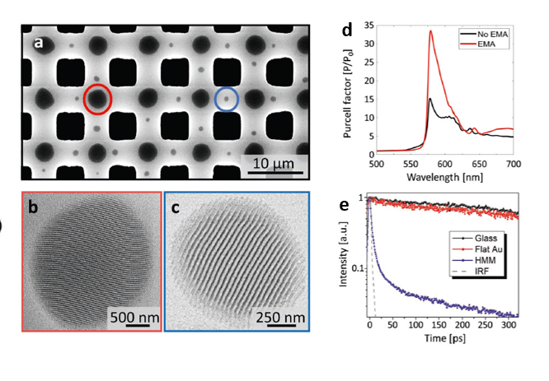
Figure 1. a) SEM image of BCP blend dewetting over a large-area substrate. (b,c) SEM images of lamellar nanostructured droplets in a single grain configuration related to highlighted areas in figures 1.a . d) Simulated Purcell factor for a vertically oriented dipole located 5 nm above the HMM. It has been computed for both the effective medium approximation (EMA) and the real lamellar structure for comparison. e) Lifetime fluorescence measurements for NV centers in nanodiamonds on glass (black), flat Au (red), and HMM (blue).
REFERENCES
[1] Murataj, I.; Channab, M.; Cara, E.; Pirri, C.F.; Boarino, L.; Angelini, A.; Ferrarese Lupi, F. Hyperbolic Metamaterials via Hierarchical Block Copolymer Nanostructures. Adv. Optical Mater. 2021, 2001933. doi:10.1002/adom.202001933.

