Effect of Au/Ag ion implantation and subsequent thermal annealing on optical properties of titanium nitride thin films

M. Popovic, M. Novakovic and V. Rajic
Department of atomic physics, Vinca Institute of Nuclear Sciences - National Institute of thе Republic of Serbia, University of Belgrade, Serbia
e-mail:majap@vin.bg.ac.rs

The control of optical properties of titanium nitride is of great interest especially in the area of plasmonics where titanium nitride can successfully change and overcome most of the drawbacks of plasmonic metals [1,2]. In this study we have investigated the structural and optical changes of 260 nm thick TiN thin film induced by sequential implantation of 200 keV Au and 150 keV Ag ions. During implantation Au ion fluence was kept constant at 1.0×10¹⁶ ions/cm² while the silver ion fluence was varied from 4.0×10¹⁶ ions/cm² to 13×10¹⁶ ions/cm². After implantation the films were annealed at 500ºC, for 1 hour. The samples were analyzed by means of X-ray diffraction and spectroscopic ellipsometry measurements. The changes in dielectric function spectra of TiN induced by Au/Ag ion implantation and post-implantation annealing were analyzed and discussed in detail. The parameters of the fit including screened and unscreened plasma frequency as well as Drude broadening were studied with respect to the ion fluences and annealing temperature, and they were correlated with the structural changes of TiN. It was found that the real part of dielectric constant becomes less negative after implantation (Fig. 1a). Simultaneously, imaginary part decreases meaning that the titanium nitride possesses lower optical losses after implantation (Fig. 1b). Besides this, the overall metallic character of titanium nitride in the visible and near infrared region is retained. Further, we have demonstrated that subsequent annealing at 500°C continues to change the both real and imaginary part of dielectric constant in the same direction as in the case of ion implantation, thus leaving the films with much lower optical losses. Our findings suggest that the optical properties of the TiN films can be tailored by varying the ion fluence of incident metal ions as well as by post-implantation annealing processing.

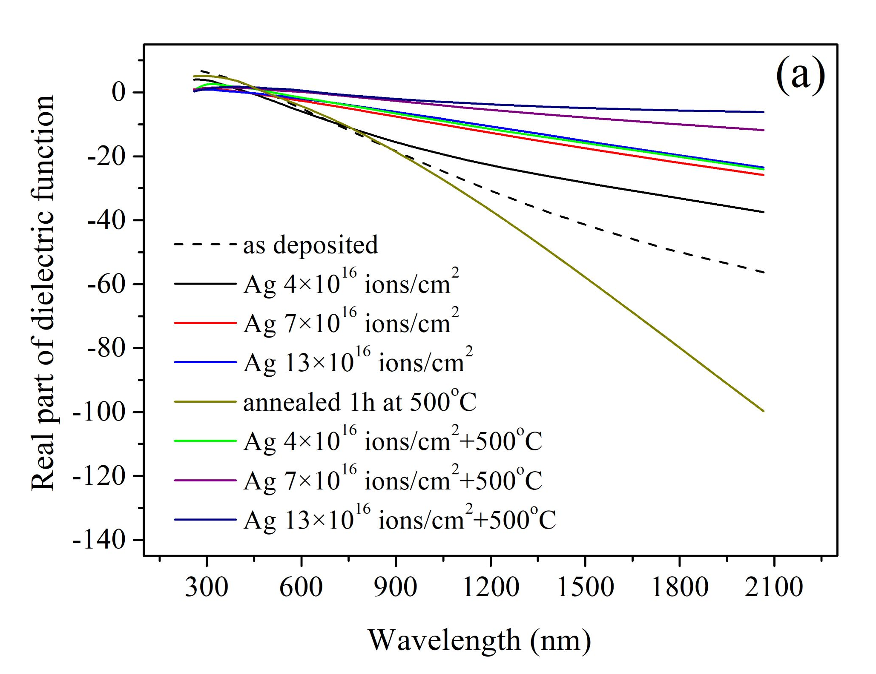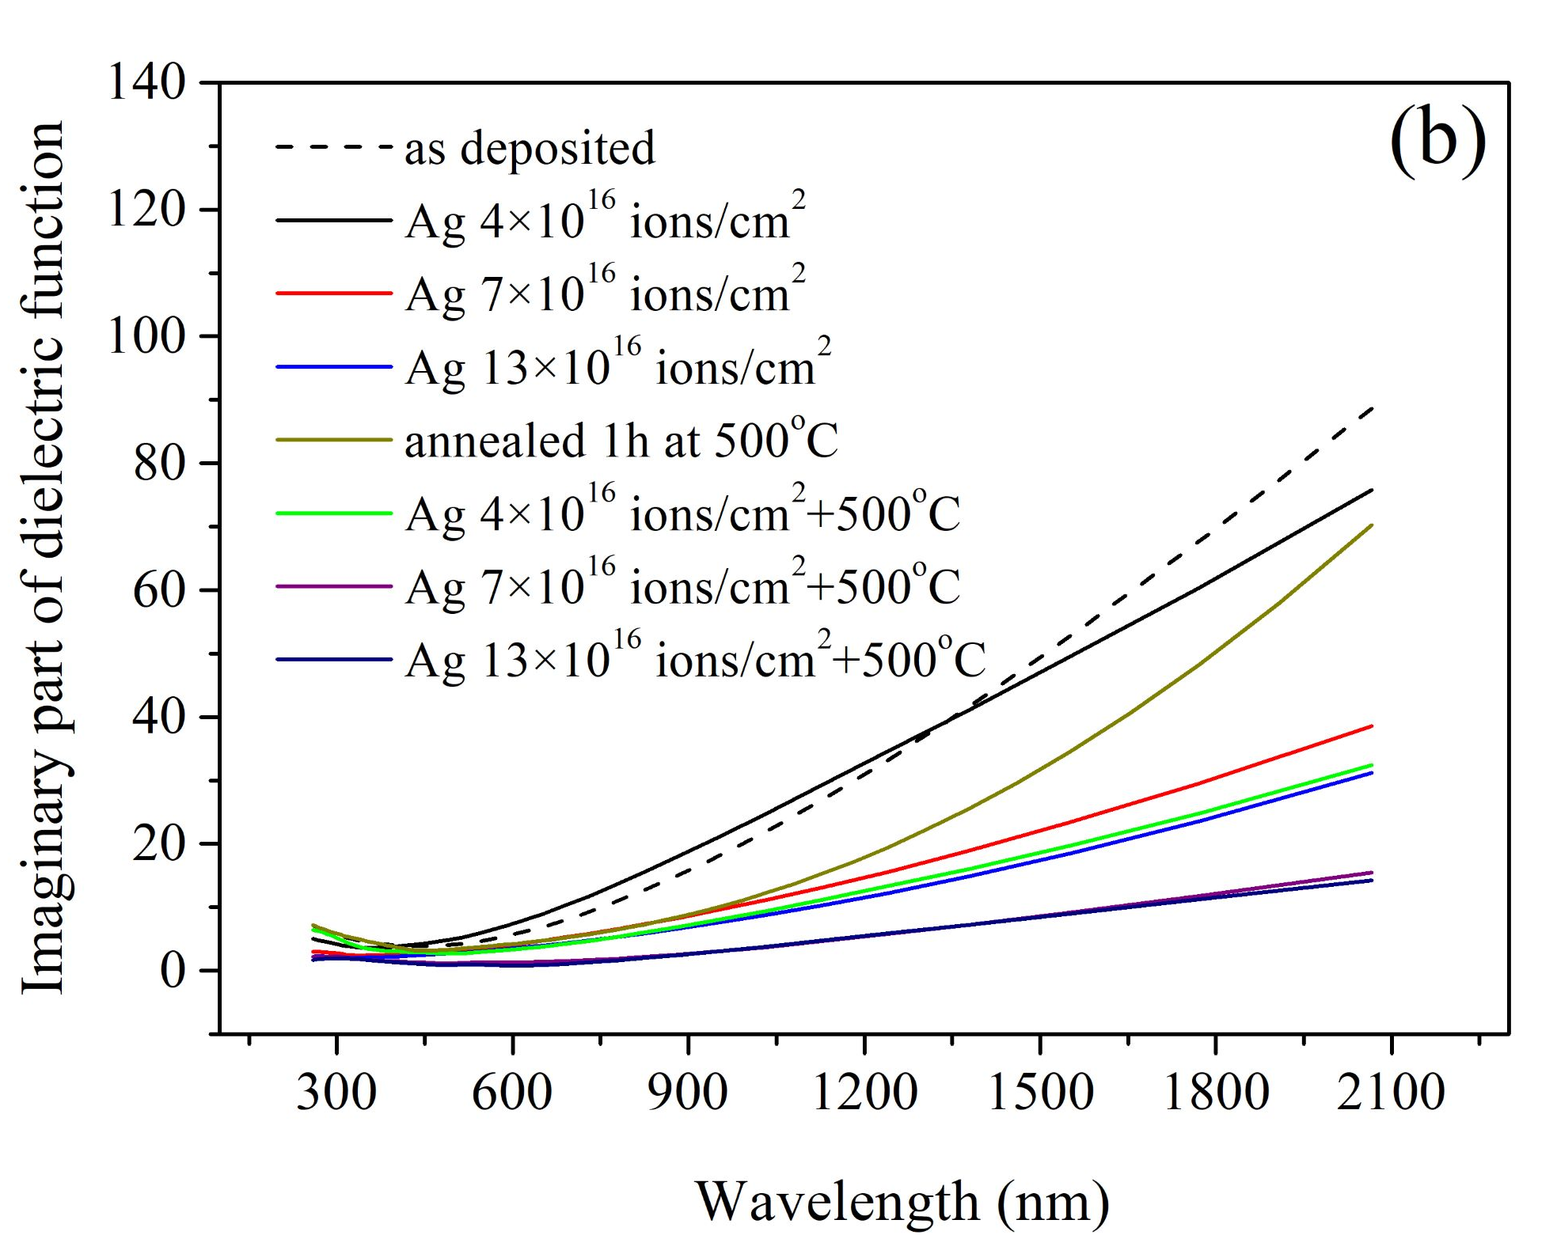
Figure 1. The real (a) and imaginary (b) part of dielectric function of as deposited, Au/Ag sequentially implanted and post-annealed TiN films. Au ion fluence was kept constant at 1.0×10¹⁶ ions/cm² whereas the silver ion fluence was varied; various colors correspond to different silver ion fluencies as indicated in the legend.

REFERENCES
[1] K.C. Maurya, V.M. Shalaev, A. Boltasseva, B. Saha, Opt. Mater. Express, 10, 2679 (2020).
[2] C.C. Chang, J. Nogan, Z.P. Yang, W.J.M. Kort-Kamp, W. Ross, T.S. Luk, D.A.R. Dalvit, A.K. Azad, and H.T. Chen, Sci. Rep. 9(1), 1 (2019).

