The surface array structures induced by femtosecond laser modifications of Ti/Cr multilayer thin films for biomedical applications

¹Suzana Petrović, ¹D. Peruško, ²A. Mimidis, ²P. Kavatzikidou, ²A. Manousaki, ¹N. Božinović, ¹V. Rajić, ²E.Stratakis

¹Vinča Institute of Nuclear Sciences, University of Belgrade, P.O.Box 522, 11001 Belgrade, Serbia
²Institute of Electronic Structure and Laser (IESL), Foundation for Research and Technology (FORTH), N. Plastira 100, Vassilika Vouton, 70013 Heraklion, Crete, Greece
e-mail: spetro@vin.bg.ac.rs

The experimental study of the static and dynamic femtosecond laser ablation of the multilayer 15x(Ti/Cr)/Si system is reported. The layer-by-layer selective laser ablation mechanism was studied by analysis of the surface morphology and elemental composition in static single pulse irradiation in a range of pulse energy from 10 – 17 μJ. The selective ablations as number of concentric circles in modified spots are increased with the pulse energy. The boundary between the circles was shown a change in the depth, comparable to the thickness of the individual layers. Changes in the elemental composition at the edges are associated with the removal of the layer by layer. Due to the intermixing of components and higher content of oxygen in the central area of ablated spots, it is expected that an ultra-thin layer composed of Ti and Cr oxide phases is formed at the bottom of the ablated center. The dynamic multi-pulse irradiation was observed via the production of lines with laser-induced periodic surface structures (LIPSS) at different laser parameters (scan velocities and laser polarization). The spatial periodicity of the formed LIPSS depends on changes in the effective number of pulses and laser polarization, as well as the nature of the material. The formation of LIPSS is followed with the significant ablation of multilayer 15x(Ti/Cr)/Si system, without visible hydrodynamic features, but ripples are somewhere covered with nanoparticles dimension up to 100 nm.
The main focus of this experimental study was examined a novel Ti/Cr nanolayered composite in order to create a biomimetic surface with suitable composition and structure for cell integration. Using SEM and confocal microscopy images of the laser modified surfaces with seeded cell culture (NIH 3T3 fibroblasts) was found that cell adhesion and their growth depend on the surface composition and morphological forms. These results indicated a good adhesion and proliferation of cells after two and four days, with some tendency of grouping of cells on the laser modified surfaces.

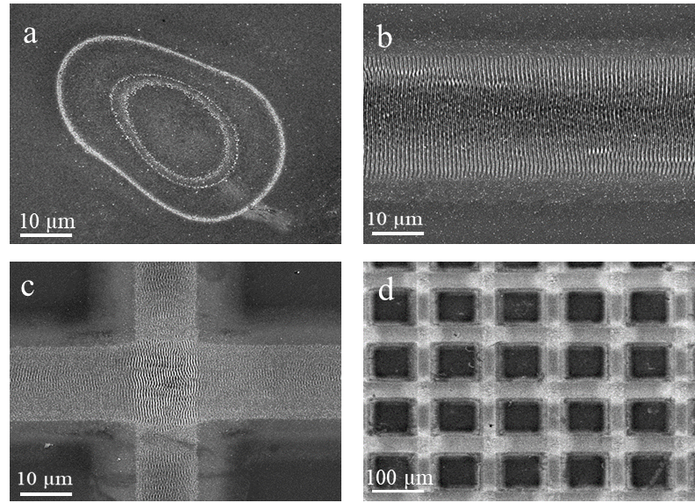

Figure 1. SEM images of 15x(Ti/Cr)/Si multilayer thin film after fs modification at the pulse energy of 15 µJ for the created: (a) spot, (b) lines, (c) crossed lines and (d) network-like structure on a larger surface.

