Influencing on optical properties of buffered TiO2-Au thin film systems by deposition and annealing parameters

N. Milicevic1, M. Novakovic1, J. Potocnik1, L. Rakocevic1, M. Milovic1, N. Abazovic1 and D. Pjevic1

1 *Vinca Institute of Nuclear Sciences - National Institute of thе Republic of Serbia, University of Belgrade, Belgrade, Serbia*

e-mail: nemanja.milicevic@vin.bg.ac.rs

One of the ways to increase efficiency of TiO2 thin films is by doping and coating with metals. Metal-doped TiO2 can reduce electron-hole recombination and increase hydroxyl radical concentration on the surface of TiO2, resulting in increase in the photocatalytic activity. Recent studies of J. Li at al. [1] and S. Y. Lee et al. [2] with Au doped TiO2 thin films showed that this systems have enhanced photocatalytic activity in comparison to pure TiO2 thin films. Also recent study[3] showed that Au doped TiO2 thin films are great candidates beside photocatalysis for enhancing visible light water splitting. TiO2 and TiO2:Au thin films were obtained by DC magnetron sputtering of Ti target with Ar ions in O2 atmosphere. In the case of doped TiO2 thin films with Au, three different systems were deposited for comparison (Fig. 1). Post deposition annealing for 3h on 400 °C was carried out in nitrogen atmosphere. For structural analyses XRD, XPS, TEM and AFM methods were used, while for optical characterization UV/Vis method was used. The photo-degradation rate was measured using Rhodamine B which simulated pollutant. Analysis of the binding energy in the corresponding XPS spectra showed that deposited films have good stoichiometry of TiO2 and that concentration of Au on the surface can be controlled by sputtering and annealing conditions. Post deposition annealing caused diffusion of Au atoms through the layer as it was shown by TEM and EDS. Obtained TiO2 thin films before deposition were amorphous-like structured, and after annealing on 400 °C showed that anatase phase dominates in the structure. All Au doped TiO2 thin films showed better photo-degradation rates then pure TiO2.

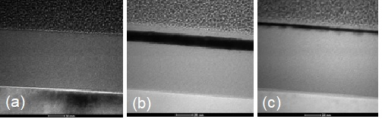 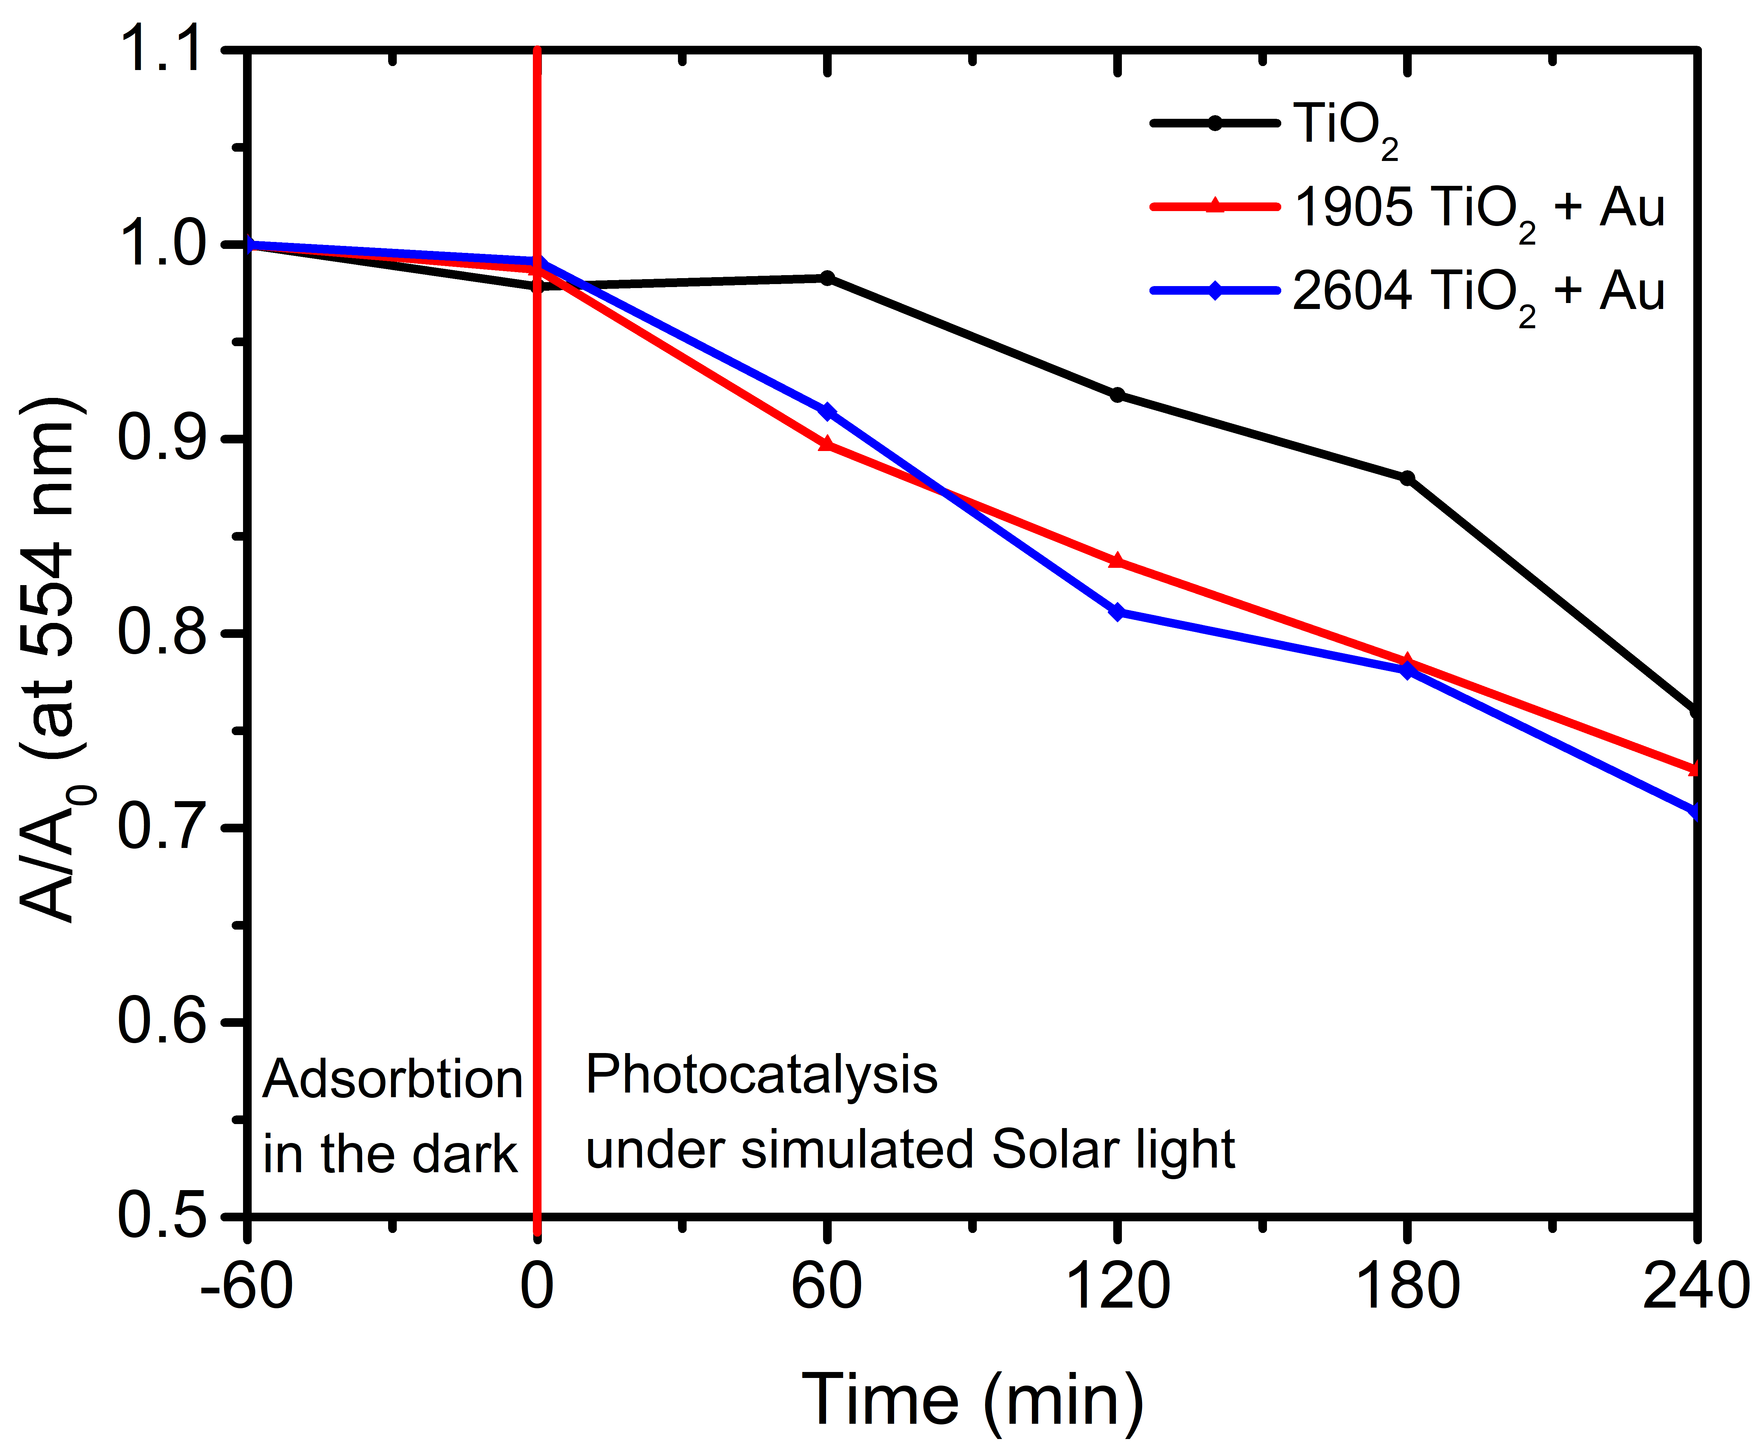

**Fig. 1.** TEM images of as-deposited TiO2 and buffered TiO2-Au systems. **Fig. 2**. Photocatalitic measurment.

REFERENCES

[1] J. Li, Z. Chen, J. Fang, Q. Yang, X. Yang, W. Zhao, D. Zhou, X. Qian, C. Liu, J. Shao, Facile synthesis of TiO2 film on glass for the photocatalytic removal of rhodamine b and tetracycline hydrochloride, Mater. Express. 9 (2019) 437–443.

[2] S. Youl Lee, D. Kang, S. Jeong, H. Tung Do, J. Heon Kim, Photocatalytic Degradation of Rhodamine B Dye by TiO2 and Gold Nanoparticles Supported on a Floating Porous Polydimethylsiloxane Sponge under Ultraviolet and Visible Light Irradiation, Cite This ACS Omega. 5 (2020) 4233–4241.

[3] A. Sreedhar, I.N. Reddy, J.H. Kwon, J. Yi, Y. Sohn, J.S. Gwag, J.S. Noh, Charge carrier generation and control on plasmonic Au clusters functionalized TiO2 thin films for enhanced visible light water splitting activity, Ceram. Int. 44 (2018) 18978–18986.