Light-induced optical effects in phosphorus, nitrogen and boron doped diamonds

K. Boldyrev¹
¹Institute of Spectroscopy of the Russian Academy of Sciences, Troitsk, Moscow, Russia
e-mail: kn.boldyrev@gmail.com

Diamond is a material with many unique properties suitable for the different applications from power electronics to quantum computing. It has an ultra-wide band gap (5.47 eV), high electron and hole mobility, high thermal conductivity, high reflectivity, transparency from RF to UV radiation, and has compelling potential advantages over the most known analogs, such as the narrow-bandgap silicon (Si), in radiation-resistant, high-power, and high-frequency electronics, as well as in deep-UV optoelectronics, synchrotron optics, quantum information, quantum sensing and extreme-environment applications [1]. As well a diamond is an excellent photoconductor, and this property can be used for UV detectors with ultra-high sensitivity [2]. It is known that p-type semiconducting diamond is synthesized by doping boron impurity. However, it used to be almost impossible to make n-type diamond. Phosphorus and nitrogen are impurities for n-type semiconducting diamond established at this moment. But nitrogen level is too deep in the bandgap for the applications (see figure), so phosphorus donor is the best candidate for the n-type diamond. P-donors in a diamond can be used for quantum computing, spin-to-photon conversion, photonic memory, integrated single-photon sources, and all-optical switches because of the read-in/read-out is in the optical region showing extremely high decoherence time up to hours [3]. Earlier studies of the photoconductivity of the phosphorus-doped diamond, which made it possible to register several electronic transitions near 600 meV [4]. These studies gave hope for the presence of photochromic effects in P-doped diamonds, by analogy with such effects in silicon [5]. In addition, based on such effects, it is possible to create a technique for the optical monitoring of the quality and concentration of doping [5,6].
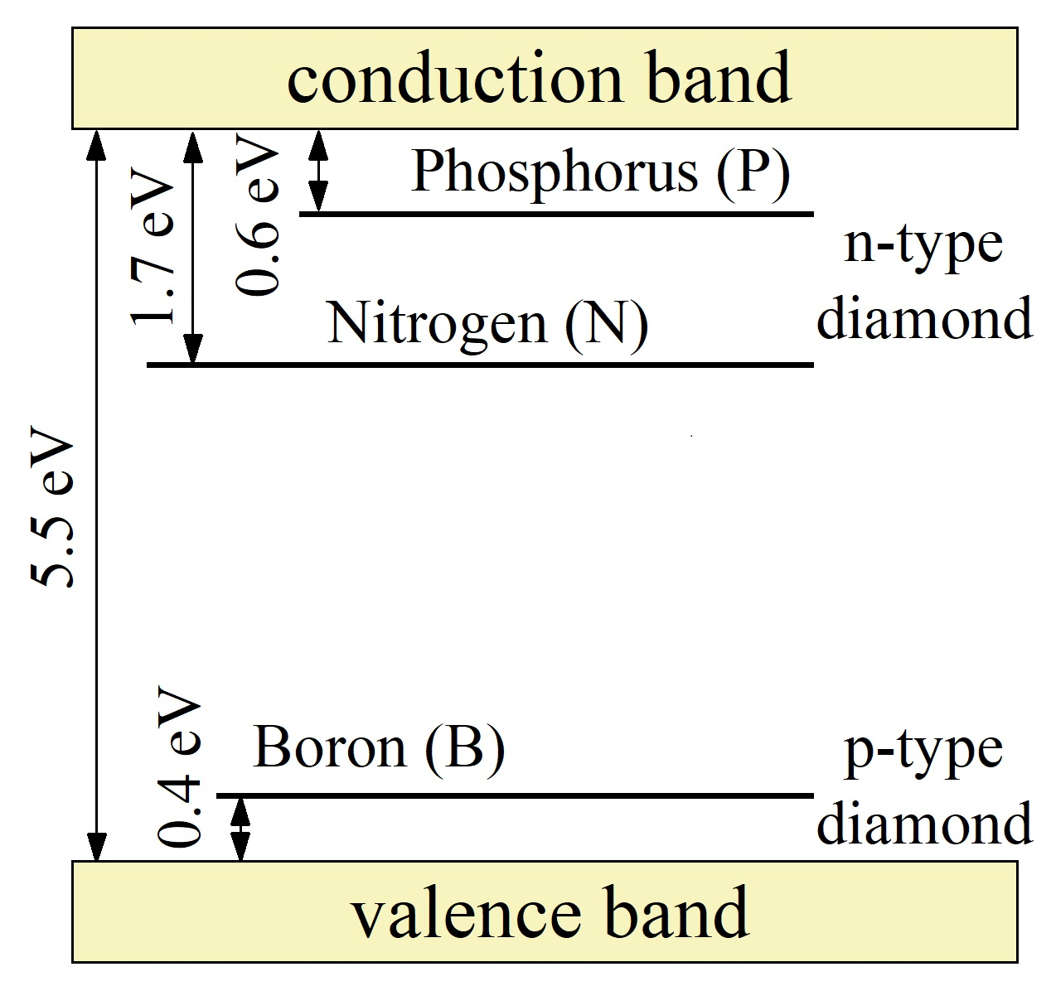
In this work, we report the detail studies of the light-induced effects of the large-sized HPHT-grown high-quality P-, B- and N-doped single-crystal diamonds by the high-resolution spectroscopy. We found a significant light-induced effect on the electronic transitions of phosphorus and boron. A strong intensity measurement in the absorption spectra is observed under the influence of external optical radiation. In addition, there was a redistribution of intensities in the absorption region of boron and phosphorus, by analogy with the dopant of boron and phosphorus in silicon [5,6]. Based on this effect, a method is proposed for determining the real concentration of boron and phosphorus in a diamond.
A financial support by the Russian Science Foundation under Grant № 19-72-10132 is acknowledged.

REFERENCES
[1] J. Y. Tsao, S. Chowdhury, M. A. Hollis et al., Adv. Electron. Mater. 4, 1600501 (2018).
[2] F. Hochedez, W. Schmutz, Y. Stockman et al., Adv. Space Res. 37(2), 303 312 (2006).
[3] K. Saeedi, S. Simmons, J. Z. Salvail et al., Science 342, 830 (2013).
[4] K. Haenen, K. Meykens, M. Nesladek et al., Phys. Stat. Sol. a 181, 11 (2000).
[5] Test method for low temperature FT-IR analysis of single crystal silicon for III-V impurities SEMI MF 1630-0704 (2004).
[6] K.N. Boldyrev, N.Yu. Boldyrev, R.V. Kirillin, Bull. Russ. Acad. Sci. Phys., 77(12), 1420 (2013).

