Colorimetric fiber-optic sensor based on reflectance spectrum estimation for determining color of printed samples

B. Batinić, J. Bajić, N. Laković, N. Kulundžić, A. Joža and M. Vasiljević Toskić
Faculty of Technical Sciences, University of Novi Sad, Novi Sad, Serbia
e-mail: banebb@uns.ac.rs

In this paper, a new colorimetric method for determining the color of printed samples obtained using digital printing is presented. The method is based on estimation of the spectrum of electromagnetic radiation (in the visible range) by interpolation of previously known radiation values at certain wavelengths. Various types of interpolation algorithms were tested in order to make a better estimation of the spectrum. Since most of the commercially available colorimeters that offer high accuracy are extremely expensive, a new sensor based on the proposed colorimetric method was developed by upgrading our previous work [1].
Hardware implementation of the realized sensor consists of a transmitting block and a receiving block. In the transmitting block, there are six LED sources radiating at different wavelengths. Signals which drive LED sources are multiplexed combining Time Division Multiplexing and Frequency Division Multiplexing. The receiving block contains a broadband photo-detector with an integrated transimpedance amplifier and an operational amplifier for further amplification of the signal before processing.
Due to the multiplexing of the transmitted signals, it is also necessary to perform digital filtering of the signal collected from the photo-detector. Butterworth IIR filters of 8th order were implemented on a microcontroller. Further processing of the filtered signals requires additional averaging for greater stability of the system, as well as better repeatability of measurement. This can be achieved by calculating the arithmetic mean, which was initially applied here, but wasn’t sufficiently efficient in terms of stability, and has also significantly slowed down the response. Thence, a more efficient solution had to be found, and it was done by implementing Kalman filter for estimation of the best measurement values [2].
The measurement probe contains transmitting and receiving optical fibers, which transmit light from the LED sources and to the photo-detector. In order to eliminate specular reflection, light sources are set at angles of 45° with respect to tested sample.
Based on the data gathered at three wavelengths (blue, green and red), interpolation was performed by inserting new points in order to approximate the configuration of the visible spectrum. One point is inserted at the beginning, one at the end of the visible spectrum, and one point between each pair of adjacent LED sources. A transformation from CIE XYZ [3] to sRGB color space was performed, and in Table 1 a visual comparison of the colors obtained by the spectrophotometric method (first row) and by the proposed method (second row) was given.
Table 1
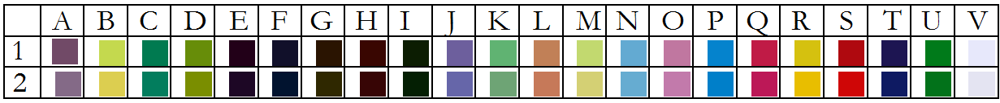

REFERENCES
[1] J. Bajić, D. Stupar, B. Dakić, L. Manojlović, M. Slankamenac and M. Živanov: Implementation and characterization of a fibre-optic colour sensor, Physica Scripta, Volume 2014, T162, Sep. 2014, doi:10.1088/0031-8949/2014/T162/014033
[2] B. Batinić, J. Bajić, V. Rajs, N. Laković, N. Kulundžić, D. Rodić, A. Joža: Implementation and signal processing of colorimetric probe, ZINC conference, Novi Sad, Serbia, (2019).
[3] R.W.G. Hunt, M.R. Pointer, "Measuring Colour", A John Wiley & Sons, Ltd., 2011.

